CCNP and CCIE Data Center Core DCCOR 350-601 Official Cert Guide
First Edition

Copyright © 2020 Cisco Systems Inc.
ISBN-10: 0-1364-4962-X
ISBN-13: 978-0-1364-4962-1
Warning and Disclaimer
Every effort has been made to make this book as complete and as accurate as possible, but no warranty or fitness is implied. The information provided is on an "as is" basis. The author and the publisher shall have neither liability nor responsibility to any person or entity with respect to any loss or damages arising from the information contained in this book or from the use of the CD or programs accompanying it.
When reviewing corrections, always check the print number of your book. Corrections are made to printed books with each subsequent printing.
First Printing: April 2020

Corrections for May 7, 2020
Page xxvii: First Paragraph from top

xxvii | Index, First Paragraph from top  Keychains Authentication 884 | Should read:  Keychains Authentication 884

Page 5: The last paragraph from the bottom
5 | Ch 1, The last paragraph from the bottom:  OSPF utilizes hello packets (multicast IPv4 244.0.0.5 or IPv6 FF02::5) for neighbor discovery. | Should read:  OSPF utilizes hello packets (multicast IPv4 224.0.0.5 or IPv6 FF02::5) for neighbor discovery.

Page 6: The third paragraph from the bottom
6 | Ch 1, The third paragraph from the bottom:  OSPFv3 redefines LAS types. OSPFv2 LSAs have seven different types (LSA type 1 to 7) and extensions (LSA 9 to 11) called Opaque, as shown in Table 1-2. | Should read:  OSPFv3 redefines LSA types. OSPFv2 LSAs have seven different types (LSA type 1 to 7) and extensions (LSA 9 to 11) called Opaque, as shown in Table 1-2.
6 | Ch 1, The key differences between the OSPFv3 and OSPFv2:  ■ OSPFv3 redefines LSA types.  ■ Bidirectional Forwarding Detection (BFD) is supported in OSPFv2 only. | Should read:  ■ OSPFv3 redefines LSA types.  ■ Bidirectional Forwarding Detection (BFD) is supported in OSPFv2 only

Page 11: Designated Routers and Backup Designated Routers
11 | Ch 1, Designated Routers and Backup Designated Routers:  OSPFv2 uses the well-known IPv4 multicast address 224.0.0.5 and the MAC address 0100.5300.0005 to communicate with neighbors, and OSPFv3 uses the well-known IPv6 multicast address FF02::5 and the MAC address 0100.5300.0005 to communicate with neighbors. | Should read:  OSPFv2 uses the well-known IPv4 multicast address 224.0.0.5 and the MAC address 0100.5e00.0005 to communicate with neighbors, and OSPFv3 uses the well-known IPv6 multicast address FF02::5 and the MAC address 3333.0000.0005 to communicate with neighbors.

Page 12: OSPF Authentication
12 | Ch 1, OSPF Authentication  OSPFv3 doesn’t have an authentication field in its header like OSPFv2; instead, OSPFv3  relies on IPsec. IPSec options for OSPFv3 authentication are not supported on Cisco  NX-OS. | Should read:  OSPFv3 doesn’t have an authentication field in its header like OSPFv2; instead, OSPFv3  relies on IPsec. IPSec options for OSPFv3 authentication are not supported on Cisco  NX-OS.

Page 14: Table 1-7:
14 | Ch 1, Table 1-7:  Insert a new row under OSFP Interface-Level Commands table (Table 1-7) | Should read:
  ip router ospf instance-tag area area-id [ secondaries none ] | Adds the interface to the OSPFv2 instance and area.
  ipv6 router ospfv3 instance-tag area area-id [ secondaries none ] | Adds the interface to the OSPFv3 instance and area.

Page 22: Example 1-7
22 | Ch 1, Example 1-7  W921-10# show ip ospf neighbors  OSPF Process ID 21 VRF default | Should read:  SW921-10# show ip ospf neighbors  OSPF Process ID 21 VRF default

Page 34: Example 1-13
34 | Ch 1, Example 1-13:  neighbor 10.10.10.1 remote-as 65100  address-family ipv4 unicast  W9621-2(config-router-neighbor-af)# show run int lo1 | Should read:  neighbor 10.10.10.1 remote-as 65100  address-family ipv4 unicast  address-family ipv4 multicast  SW9621-2(config-router-neighbor-af)# show run int lo1

Page 32: Figure 1-5 & Example 1-11
32 | Ch 1, Figure 1-5:  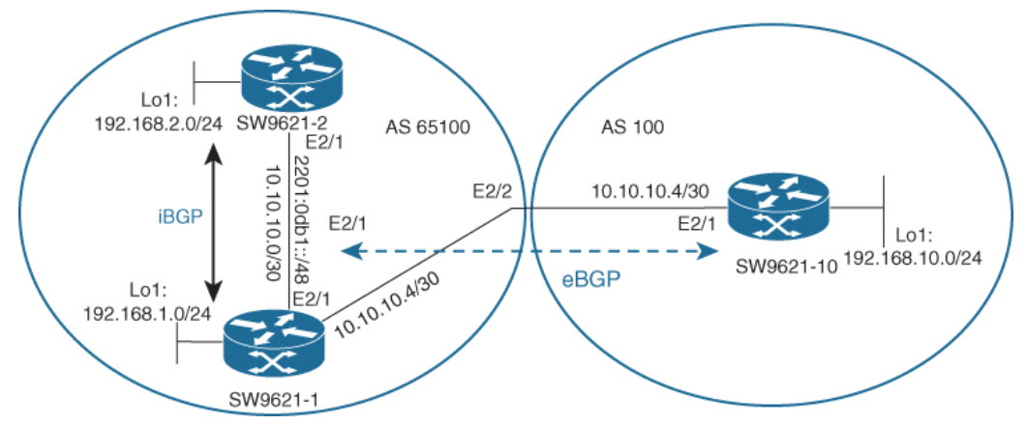 | Should read:  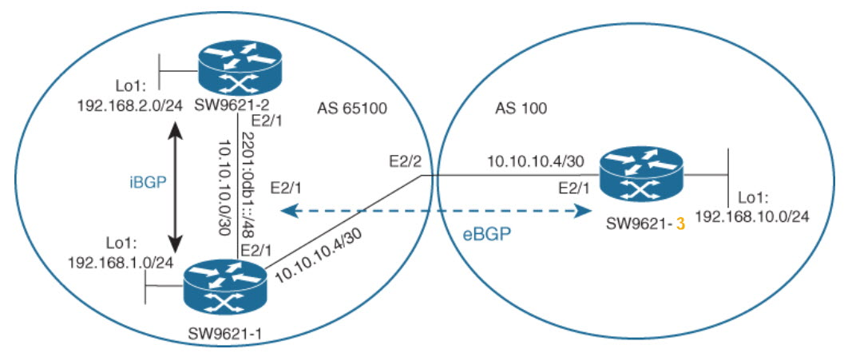
32 | Ch 1, Example 1-11:  SW9621-1(config)# interface Ethernet2/1  SW9621-1(config-if)# ip address 10.10.10.1/30  SW9621-1(config-if)# no shutdown | Should read:  SW9621-1(config)# interface Ethernet2/1  SW9621-1(config-if)# ip address 10.10.10.1/30  SW9621-1(config-if)# no shutdown  SW9621-1(config)# interface Ethernet2/2  SW9621-1(config-if)# ip address 10.10.10.5/30  SW9621-1(config-if)# no shutdown

Page 35: Example 1-14
35 | Ch 1, Example 1-14:  SW9621-3(config-router-neighbor-af)# show run int e2/1  interface Ethernet2/1  no switchport  mac-address 0000.0000.002f  ip address 10.10.10.6/30  no shutdown | Should read:  SW9621-3(config-router-neighbor-af)# show run int e2/1  interface Ethernet2/1  no switchport  mac-address 0000.0000.0023f  ip address 10.10.10.6/30  no shutdown

Page 37: Figure 1-7 & Table 1-14
37 | Ch 1, Figure 1-7:  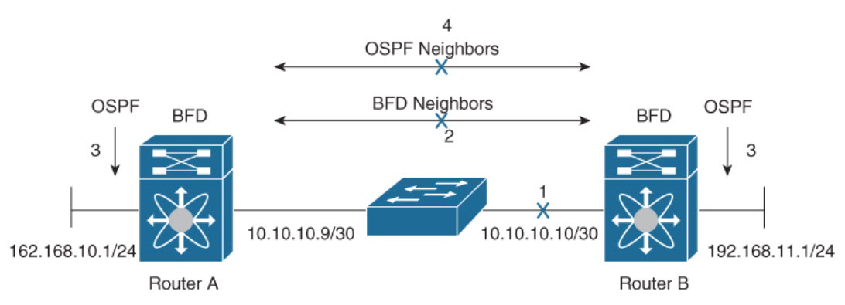 | Should read:  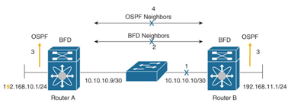
37 | Ch 1, Table 1-14:  Table 1-14 lists OSPFv2/v3 default parameters; you can alter OSPF parameters as necessary. | Should read:  Table 1-14 lists OSPFv2/v3BFD default parameters; you can alter OSPFBFD parameters as necessary.

Page 38: BFD Configurations and Verifications
38 | Ch1, BFD Configurations and Verifications  BFD has the following configuration limitations:  ■ NX-OS supports BFD version 1.  ■ NX-OS supports IPv4 only. | Should read:  BFD has the following configuration limitations:  ■ NX-OS supports BFD version 1.  ■ NX-OS supports IPv4 only.

Page 43:
43 | Ch 1, Figure 1-11:  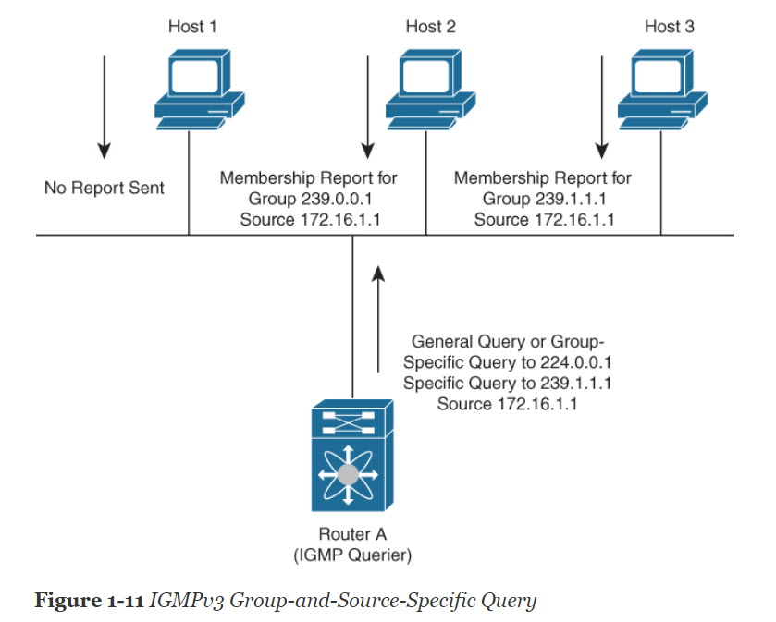 | Should read:  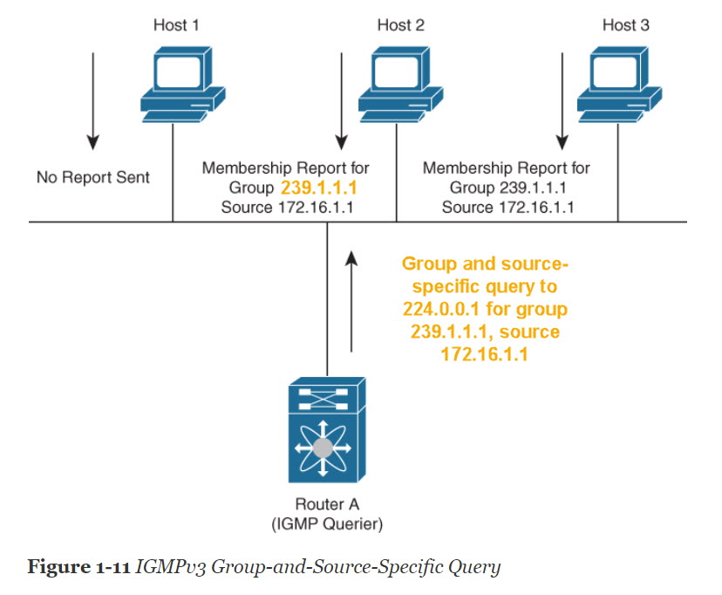

Page 46:
46 | Ch 1, Figure 1-12:  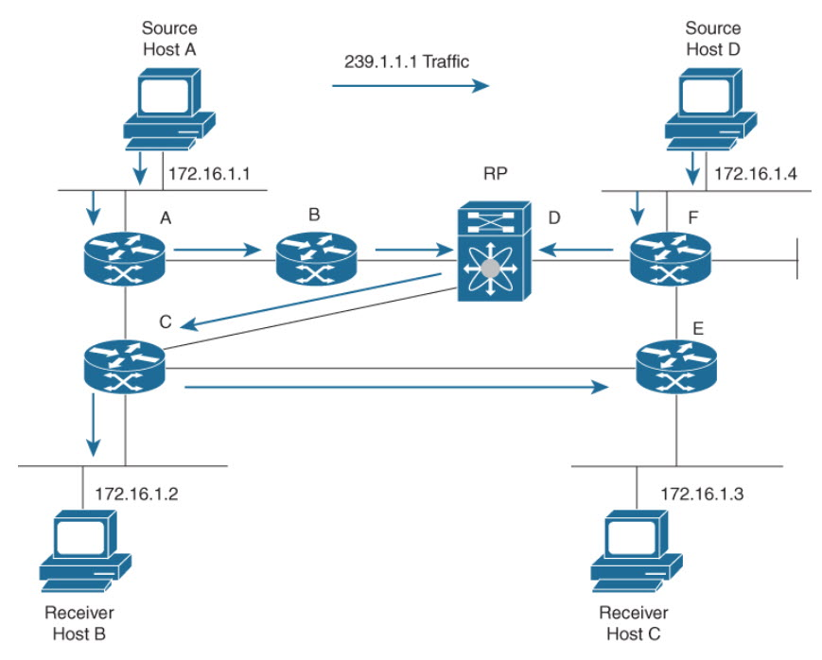 | Should read:  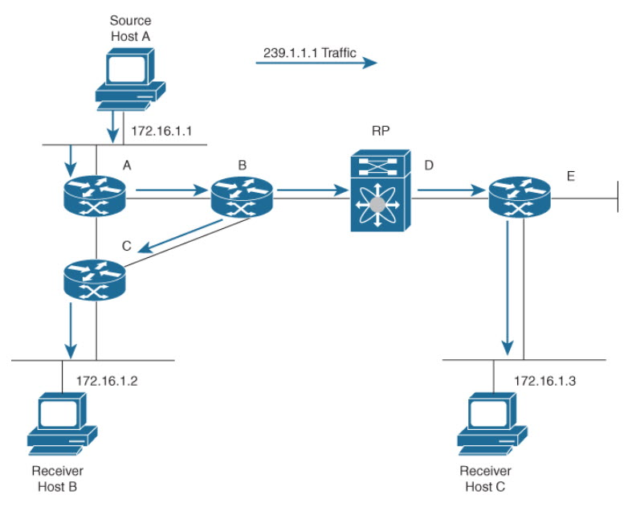  Swap the Figure 1-12 with Figure 1-13

Page 47: Figure 1-13
47 | Ch 1, Figure 1-13: | Should read:  Swap the Figure 1-13 with Figure 1-12

Page 60: Figure 1-18
60 | Ch 1, Figure 1-18:  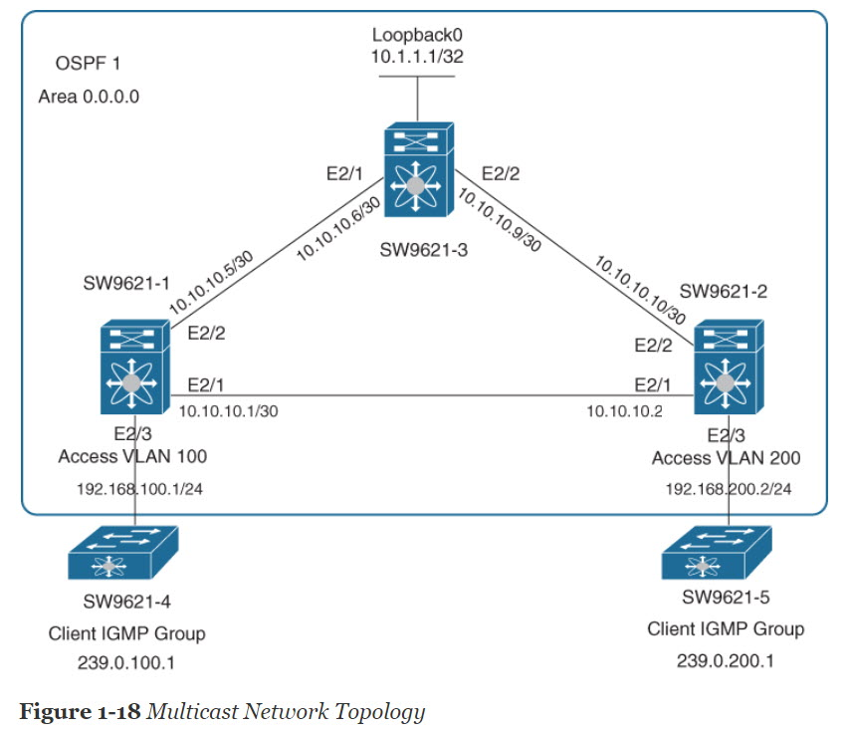 | Should read:  (Prod: This error is fixed on ebook seems like, but its there on hardcopy)  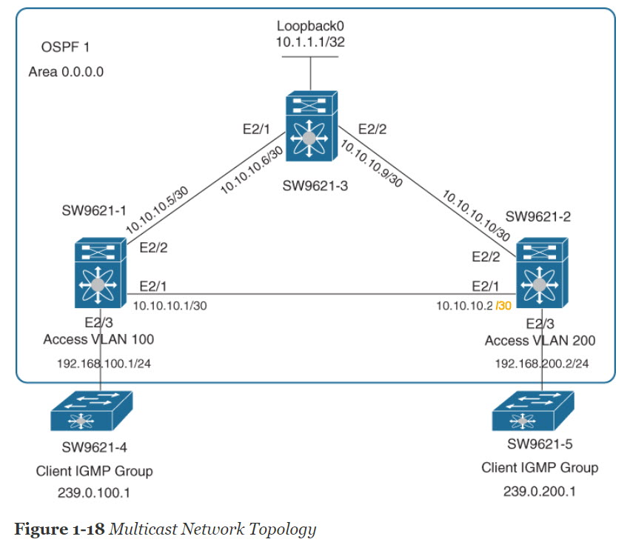

Page 61: Example 1-18
61 | Ch 1, Example 1-18:  SW9621-1(config)# int e2/3  SW9621-1(config-if)# switch port mode access  SW9621-1(config-if)# switch access vlan 100 | Should read:  SW9621-1(config)# interface e2/3  SW9621-1(config-if)# switchport mode access  SW9621-1(config-if)# switchport access vlan 100

Page 63: Example 1-19
63 | Ch 1, Example 1-19:  SW9621-2(config)# interface e2/3  SW9621-2(config-if)# switch port mode access  SW9621-2(config-if)# switch access vlan 100 | Should read:  SW9621-2(config)# interface e2/3  SW9621-2(config-if)# switchport mode access  SW9621-2(config-if)# switchport access vlan 200

Page 65: Example 1-21 & Example 1-22
65 | Ch 1, Example 1-21:  SW9621-2(config)# ip pim rp 10.10.10.2 group-list 339.0.200.0/24 | Should read:  SW9621-1(config)# ip pim rp 10.10.10.6 group-list 239.0.200.0/24

Page 66: Example 1-23
66 | Ch 1, Example 1-23:  SW9621-2(config)# ip pim auto-rp mapping-agnet e2/1  SW9621-2(config)# ip pim auto-rp forward listen  W9621-2(config)# show ip pim rp | Should read:  SW9621-2(config)# ip pim auto-rp mapping-agent e2/1  SW9621-2(config)# ip pim auto-rp forward listen  SW9621-2(config)# show ip pim rp

Page 67: Example 1-24
67 | Ch 1, Example 1-24:  SW9621-2(config)# ip pim auto-rp mapping-agnet e2/1 | Should read:  SW9621-2(config)# ip pim auto-rp mapping-agent e2/1
67 | Ch 1, Example 1-24:  Anycast-RP 10.1.1.1 members:  10.10.10.2 10.10.10.9* | Should read:  Anycast-RP 10.1.1.1 members:  10.10.10.6 10.10.10.9*

Page 72:
72 | Ch 1, The second paragraph from the bottom:  As the master, router A owns the virtual IP address of the VRRP group r and forwards packets sent to this IP address. | Should read:  As the master, router A owns the virtual IP address of the VRRP group r and forwards packets sent to this IP address.
72 | Ch 1, The first paragraph from the bottom:  When router A recovers, it becomes the r master again. | Should read:  When router A recovers, it becomes the r master again.

Page 77: The third paragraph from the top
77 | Ch 1, The third paragraph from the top:  3. If the link between router A fails or the link between router A and client 2 fails, client 2 will not receive any RA message from router A anymore. It will continue sending traffic and keep router A as a default router until the lifetime expires (the lifetime sent to client 2 from router A via RA message data); the default lifetime is 30 minutes. | Should read:  3. If the link between router A fails or the link between router A and client 2 fails, client 2 will not receive any RA message from router A anymore. It will continue sending traffic to Router A and will keep router A as a default router until the lifetime expires (the lifetime sent to client 2 from router A via RA message data); the default lifetime is 30 minutes.

Page 79:
79 | Ch 1, Table 1-29:  The line-protocol keyword tracks whether the interface is up. The ip keyword also checks that IP routing is enabled on the interface and an IP address is configured. | Should read:  The line-protocol keyword tracks whether the interface is up. The ip routing keyword also checks that IP routing is enabled on the interface and an IP address is configured.
79 | Ch 1, Table 1-30:  hsrp-<interface-short-name>-<group-id>. For example, hsrp-Eth3/1. | Should read:  hsrp-<interface-short-name>-<group-id>. For example, hsrp-Eth3/1-10.

Page 83: Example 1-28
83 | Ch 1, Example 1-28:  SW9621-2(config)# interface e2/2  SW9621-2(config-if)# ip address 192.168.20.2/24 | Should read:  SW9621-2(config)# interface e2/2  SW9621-2(config-if)# ip address 192.168.20.3/24
83 | Ch 1, Example 1-28:  SW9621-2(config)# interface e2/3  SW9621-2(config-if)# ip address 192.168.30.2/24 | Should read:  SW9621-2(config)# interface e2/3  SW9621-2(config-if)# ip address 192.168.30.3/24

Page 99: The fifth paragraph from the top
99 | Ch 2, The fifth paragraph from the top:  Normally, the TC bit is set by the root for a period of max_age + forward_delay seconds, which is 10+15=35 seconds by default. | Should read:  Normally, the TC bit is set by the root for a period of max_age + forward_delay seconds, which is 20+15=35 seconds by default.

Page 102: The third paragraph from the top
102 | Ch 2, The third paragraph from the top:  Table 2-4 lists STP default parameters, and Table 2-5 lists Rapid PVST+ and UDLS default parameters. You can alter these parameters as necessary to optimize protocol functionality. | Should read:  Table 2-4 lists STP default parameters, and Table 2-5 lists Rapid PVST+ and UDLD default parameters. You can alter these parameters as necessary to optimize protocol functionality.

Page 107: Table 2-7
107 | Ch 2, Table 2-7:  spanning-tree guard loop  Enables or disables either Loop Guard or Root Guard for the specified interface. Root Guard is disabled by default, and Loop Guard on specified ports is also disabled.  NOTE: Loop Guard runs only on spanning tree normal and network interfaces. This example shows Loop Guard is enabled on the specified interface. | Should read:  spanning-tree guard loop  Enables or disables either Loop Guard or Root Guard for the specified interface. Root Guard is disabled by default, and Loop Guard on specified ports is also disabled by default.  NOTE: Loop Guard runs only on spanning tree normal and network interfaces. This example shows Loop Guard is enabled on the specified interface.
 | Ch 2, Table 2-7:  spanning-tree guard root  Enables or disables either Loop Guard or Root Guard for the specified interface. Root Guard is disabled by default, and Loop Guard on specified ports is also disabled. | Should read:  spanning-tree guard root  Enables or disables either Loop Guard or Root Guard for the specified interface. Root Guard is disabled by default, and Loop Guard on specified ports is also disabled.

Page 108: The first paragraph from the bottom
108 | Ch 2, The first paragraph from the bottom:  Example 2-1 shows the spanning tree configuration for the root switch (SW9621-1). The configuration changes the default spanning tree port to a network port and enables default bpdugard and pbdufilter for edge ports. | Should read:  Example 2-1 shows the spanning tree configuration for the root switch (SW9621-1). The configuration changes the default spanning tree port to a network port and enables default bpdugard and bpdufilter for edge ports.

Page 113: The first paragraph from the top
113 | Ch 2, The first paragraph from the top:  Example 2-4 shows spanning tree configurations for the second switch (SW9621-2). The configuration changes the default spanning tree port to a network port and enables bpdugard and pbdufilter for edge ports. | Should read:  Example 2-4 shows spanning tree configurations for the second switch (SW9621-2). The configuration changes the default spanning tree port to a network port and enables bpdugard and bpdufilter for edge ports.
113 | Example 2-6  W9621-2# show spanning-tree summary | Should read:  SW9621-2# show spanning-tree summary

Page 115: The first paragraph from the top
115 | Ch 2, The first paragraph from the top:  Example 2-7 shows the spanning tree configuration for the third switch (SW9621-3). The configuration changes the default spanning tree port to a network port and enables bpdugard and pbdufilter for the edge ports. | Should read:  Example 2-7 shows the spanning tree configuration for the third switch (SW9621-3). The configuration changes the default spanning tree port to a network port and enables bpdugard and bpdufilter for the edge ports.

Page 117: Example 2-9
117 | Ch 2, Example 2-9:  Interface Role Sts Cost Prio.Nbr Type  ---------------- ---- --- --------- --------  Eth2/1 Root FWD 4 128.257 Network P2p  Eth2/2 Altn BLK 4 128.258 Network P2p  Eth2/3 Desg BKN* 4 128.259 Network P2p *BA_Inc | Should read:  Interface Role Sts Cost Prio.Nbr Type  ---------------- ---- --- --------- --------  Eth2/1 Root FWD 4 128.257 Network P2p  Eth2/2 Altn BLK 4 128.258 Network P2p  Eth2/3 Desg FWD 4 128.259 Edge P2p

Page 118 The first paragraph from the top
118 | Ch 2, The first paragraph from the top:  Link Aggregation Control Protocol (LACP). LACP is defined in IEEE 802.3a and is more efficient than Static because the LACP link passes protocol packets. | Should read:  Link Aggregation Control Protocol (LACP). LACP is defined in IEEE 802.3ad and is more efficient than Static because the LACP link passes protocol packets.

Page 137: Figure 2-13
137 | Ch 2, Figure 2-13:  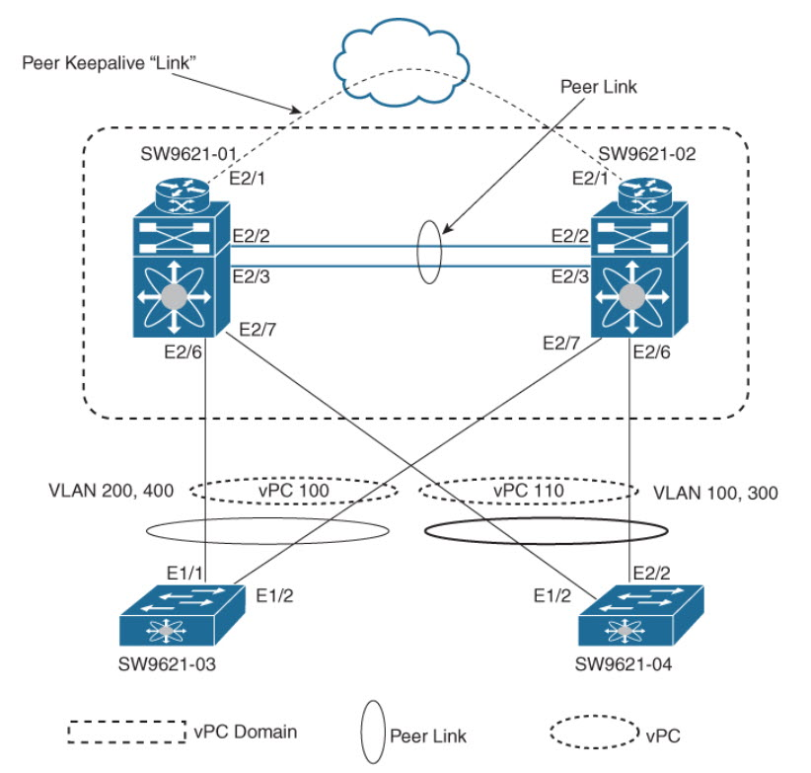 | Should read:  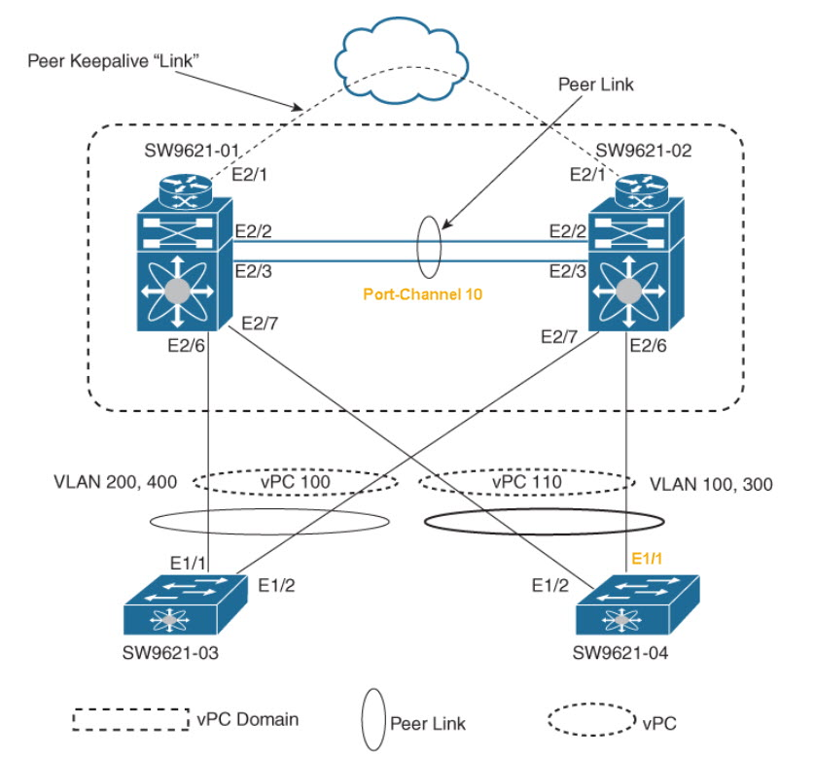

Page 139: Example 2-11
139 | Ch 2, Example 2-11:  SW9621-02(config)# interface Ethernet2/6  SW9621-02(config-if)# channel-group 110 mode active  SW9621-02(config-if)# no shutdown  SW9621-02(config)# interface Ethernet2/7  SW9621-02(config-if)# channel-group 100 mode on  SW9621-02(config-if)# no shutdown | Should read:  SW9621-02(config)# interface Ethernet2/6  SW9621-02(config-if)# channel-group 110 mode on  SW9621-02(config-if)# no shutdown  SW9621-02(config)# interface Ethernet2/7  SW9621-02(config-if)# channel-group 100 mode active  SW9621-02(config-if)# no shutdown

Page 140: Example 2-13
140 | Ch 2, Example 2-13:  SW9621-04(config)# feature lacp  SW9621-04(config)# interface port-channel110  SW9621-04(config-if)# switchport  SW9621-04(config-if)# switchport mode trunk  SW9621-04(config-if)# switchport trunk allowed vlan 100,300  SW9621-04(config-if)# no shutdown  SW9621-04(config)# interface port-channel110  SW9621-04(config-if)# switchport  SW9621-04(config-if)# switchport mode trunk  SW9621-04(config-if)# switchport trunk allowed vlan 100,300  SW9621-04(config-if)# no shutdown  SW9621-04(config)# interface Ethernet1/1-2  SW9621-04(config-if)# channel-group 100 mode active  SW9621-04(config-if)# no shutdown | Should read:  SW9621-04(config)# feature lacp  SW9621-04(config)# interface port-channel110  SW9621-04(config-if)# switchport  SW9621-04(config-if)# switchport mode trunk  SW9621-04(config-if)# switchport trunk allowed vlan 100,300  SW9621-04(config-if)# no shutdown  SW9621-04(config)# interface port-channel110  SW9621-04(config-if)# switchport  SW9621-04(config-if)# switchport mode trunk  SW9621-04(config-if)# switchport trunk allowed vlan 100,300  SW9621-04(config-if)# no shutdown  SW9621-04(config)# interface Ethernet1/1-2  SW9621-04(config-if)# channel-group 110 mode on  SW9621-04(config-if)# no shutdown

Page 143: Example 2-14
143 | Ch 2, Example 2-14:  10 Po10(SU) Eth LACP Eth2/2(P) Eth2/4(P)  100 Po100(SU) Eth LACP Eth2/6(P)  110 Po110(SU) Eth NONE Eth2/7(P) | Should read:  10 Po10(SU) Eth LACP Eth2/2(P) Eth2/3(P)  100 Po100(SU) Eth LACP Eth2/6(P)  110 Po110(SU) Eth NONE Eth2/7(P)

Page 145: Example 2-16
145 | Ch 2, Example 2-16:  SW9621-02  Eth1/2 165 R S I s N7K-C7009 Eth2/6 | Should read:  SW9621-02  Eth1/2 165 R S I s N7K-C7009 Eth2/7

Chapter 3:
Page 155: Figure 3-3
155 | Ch 3, Figure 3-3:  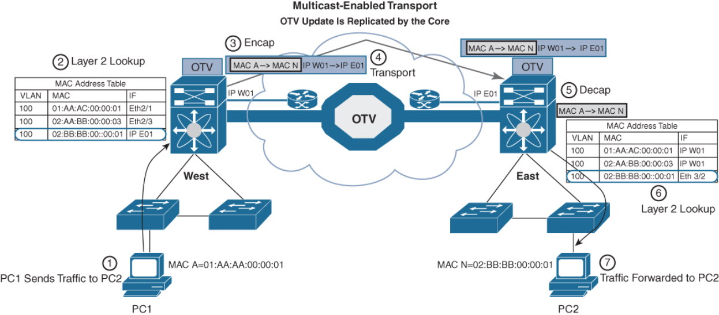 | Should read:  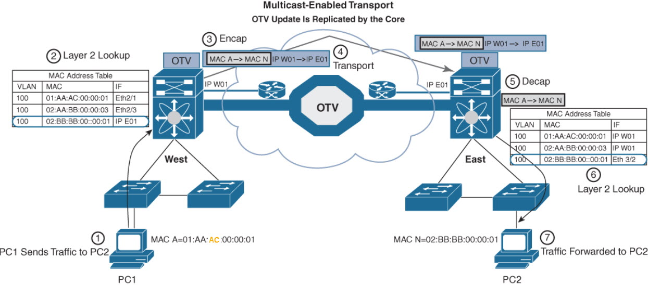

Page 158: Figure 3-5
158 | Ch 3, Figure 3-5:  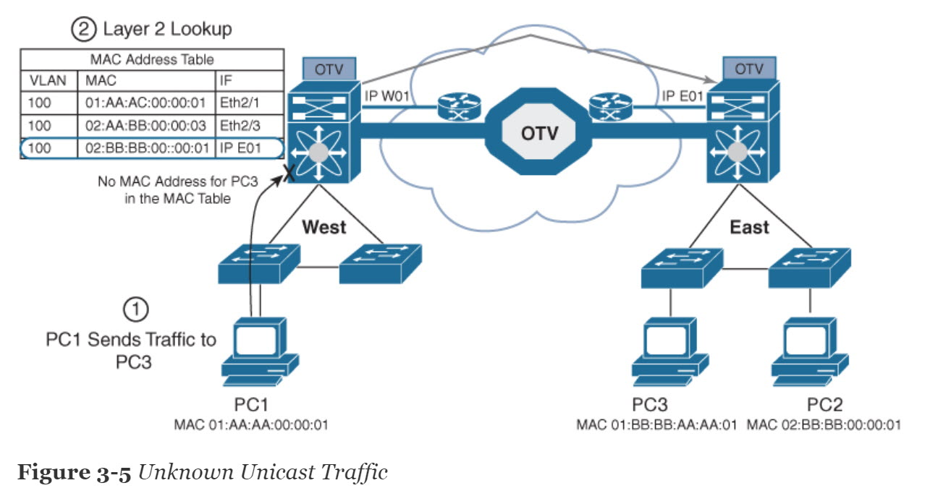 | Should read:  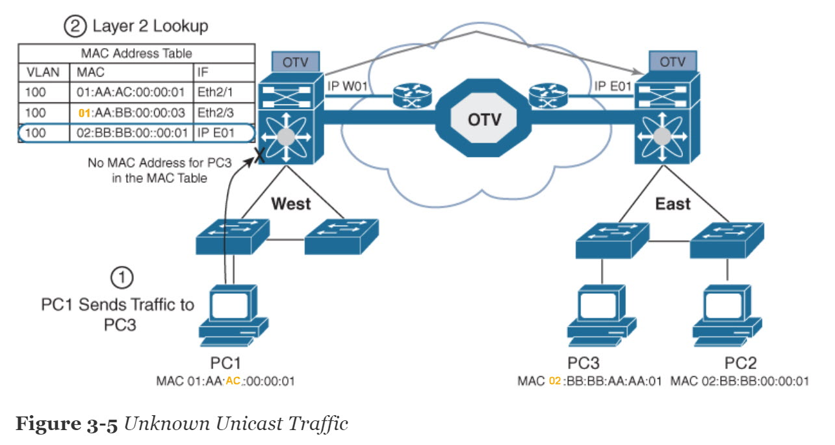

Page 159: Figure 3-6
159 | Ch 3, Figure 3-6:  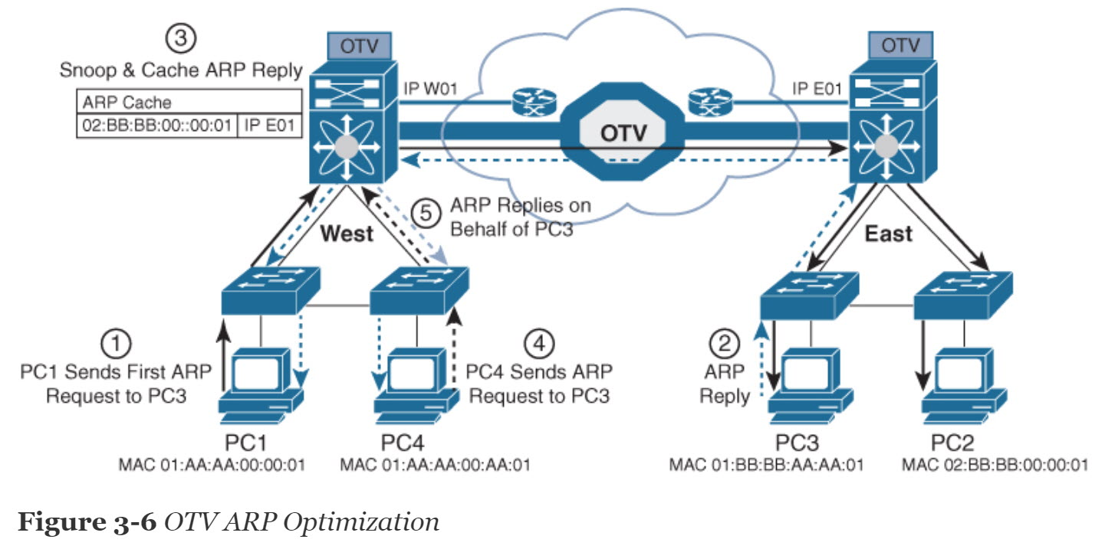 | Should read:  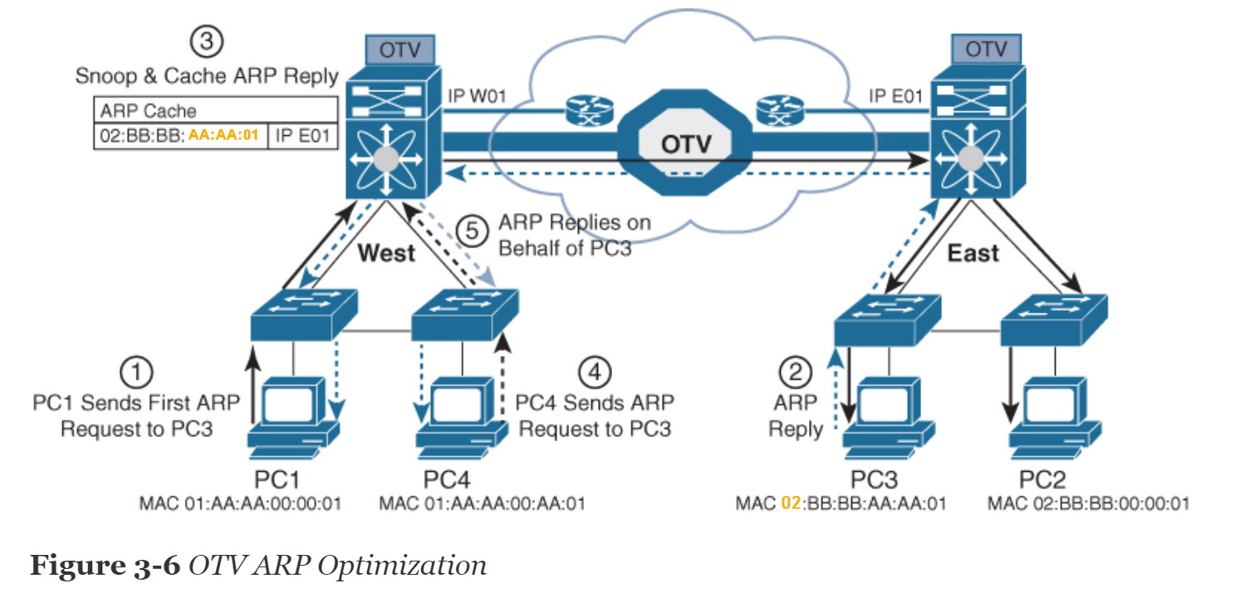

Page 160:
160 | Ch 3, Figure 3-7:  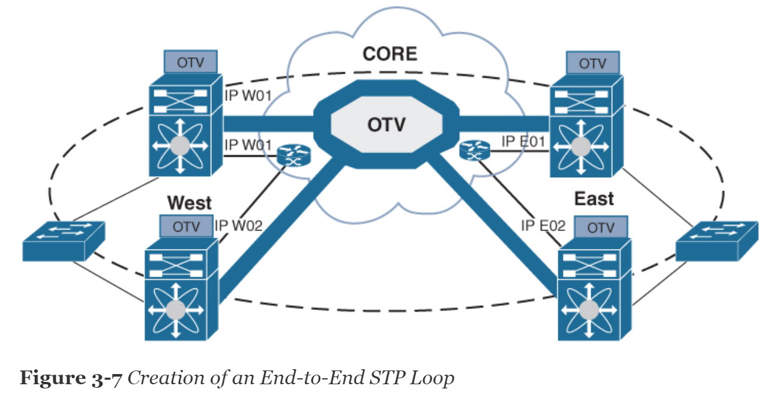 | Should read:  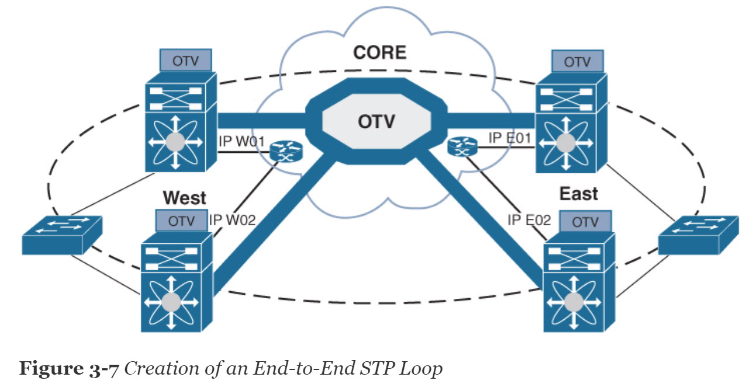  Duplicated naming (IP W01) removed
160 | Ch 3, Figure 3-8:  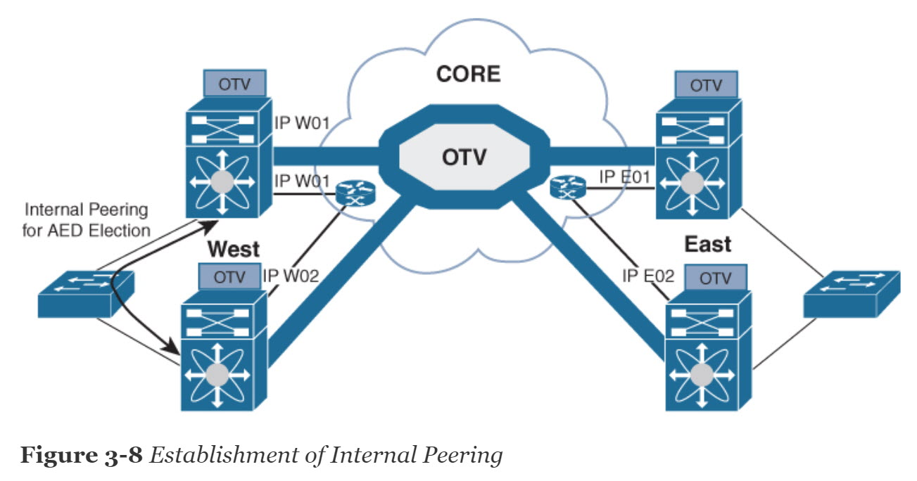 | Should read:  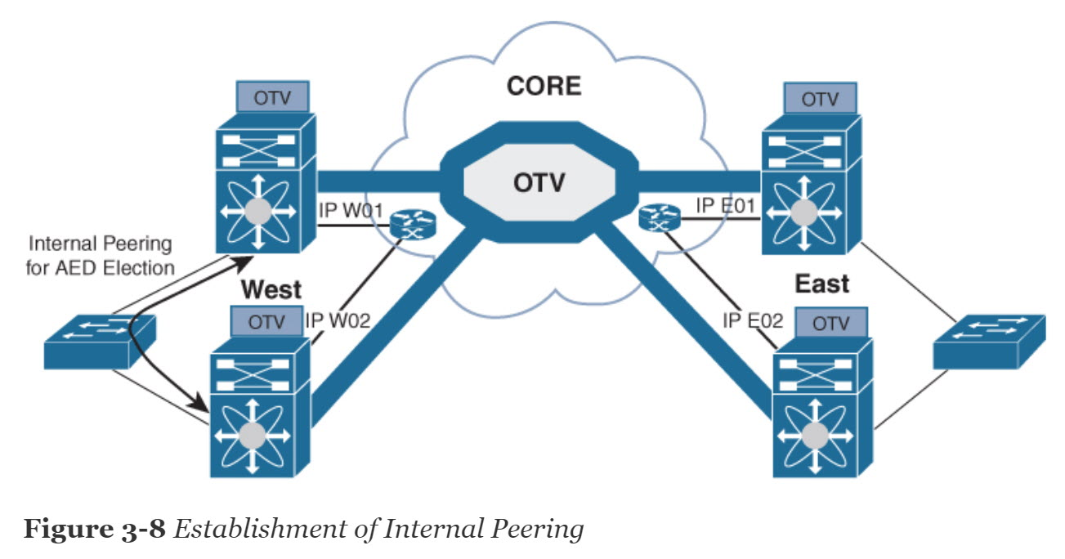  Duplicated naming (IP W01) removed

Page 162: Figure 3-10
162 | Ch 3, Figure 3-10:  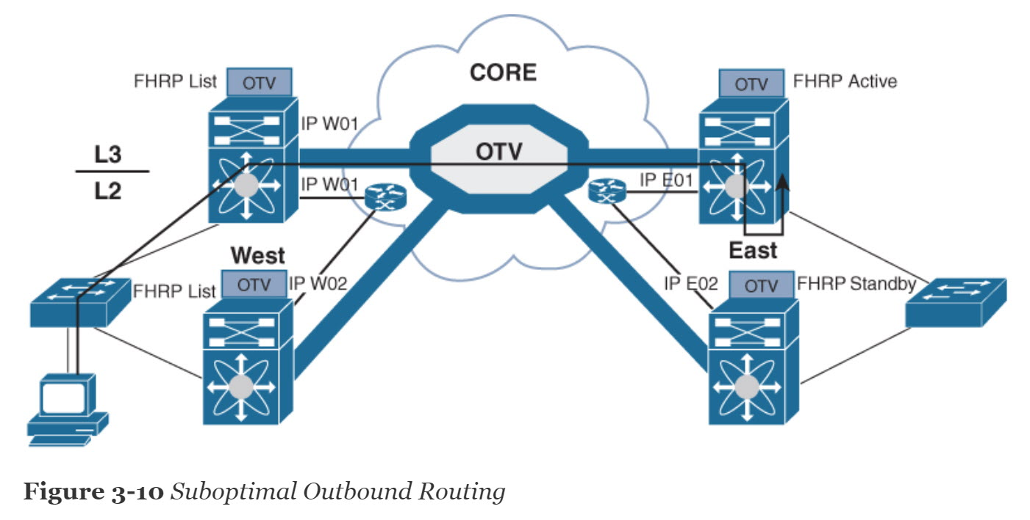 | Should read:  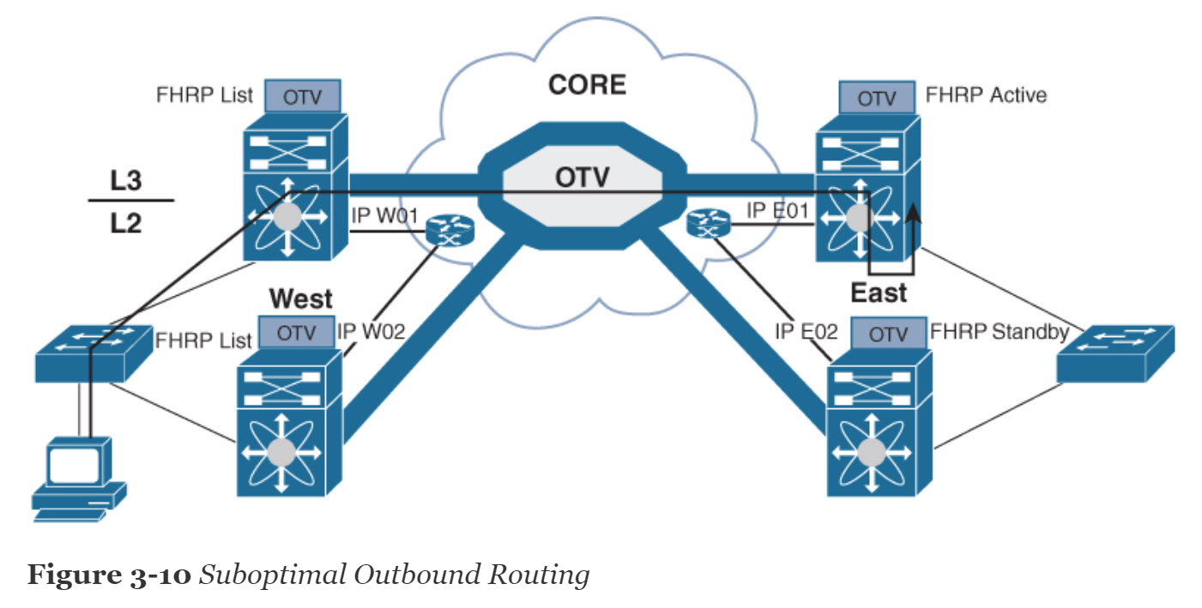  Duplicated naming (IP W01) removed

Page 163: Figure 3-11
163 | Ch 3, Figure 3-11:  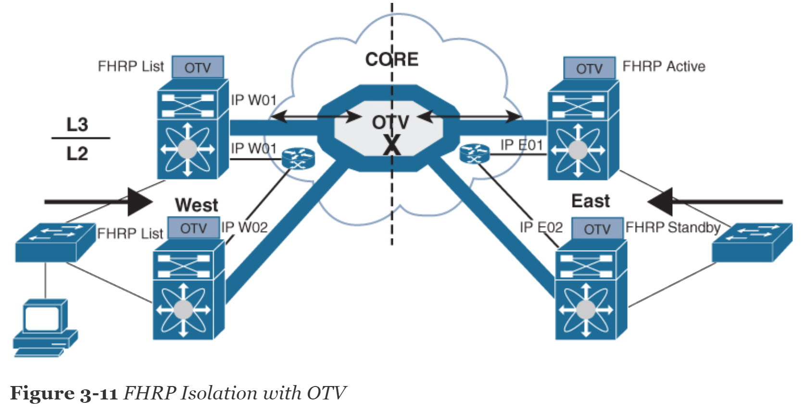 | Should read:  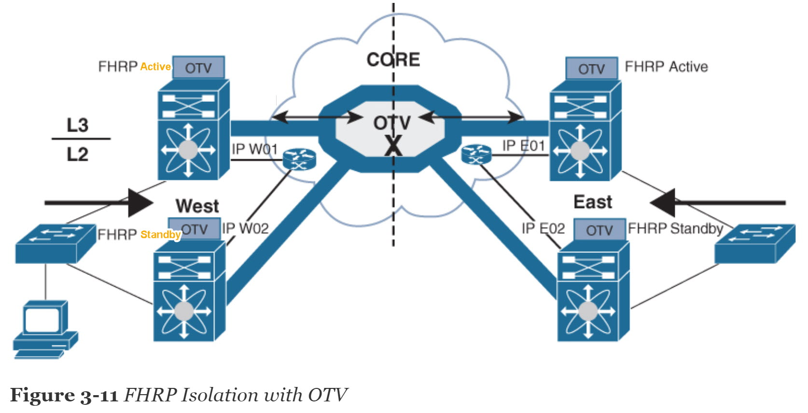  Duplicated naming (IP W01) removed and corrections done

Page 167: Table 3-5
167 | Ch 3, Table 3-5: | Should read:  Duplicated command on pages 166-167 in Table 3-5. Removed the command on Page 167
  otv site-vlan vlan-id | Configures a VLAN that all local edge devices communicate on. You must configure this VLAN ID on all local edge devices. The range is from 1 to 3967 and from 4048 to 4093. The default is 1.
  otv site-vlan vlan-id | Configures a VLAN that all local edge devices communicate on. You must configure this VLAN ID on all local edge devices. The range is from 1 to 3967 and from 4048 to 4093. The default is 1.

Page 171: The first paragraph from the top
171 | Ch 3, The first paragraph from the top:  Example 3-2 shows switch two at at West site (SW9621-W2) with OTV information. | Should read:  Example 3-2 shows switch two at at the West site (SW9621-W2) with OTV information.

Page 185: Figure 3-19
185 | Ch 3, Figure 3-19:  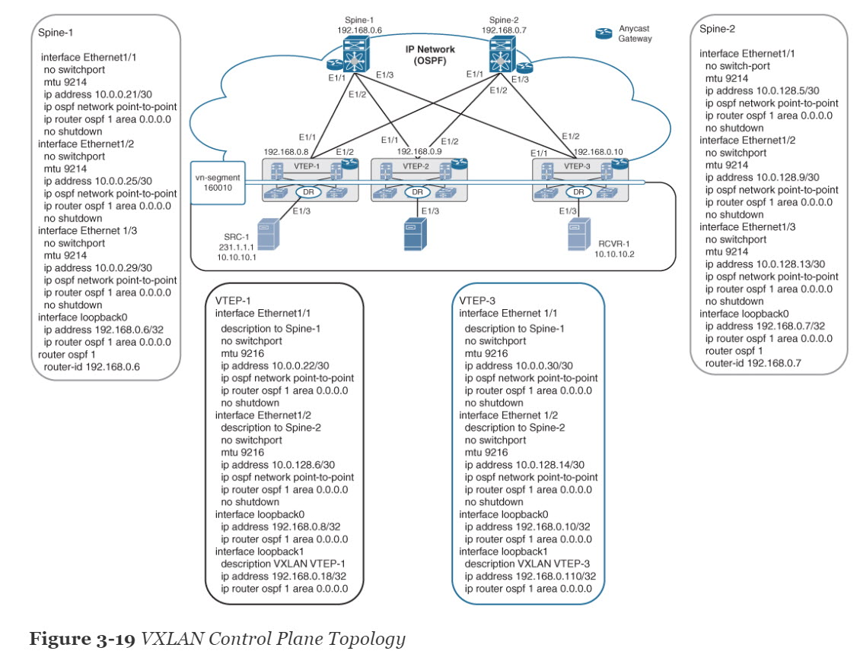 | Should read:  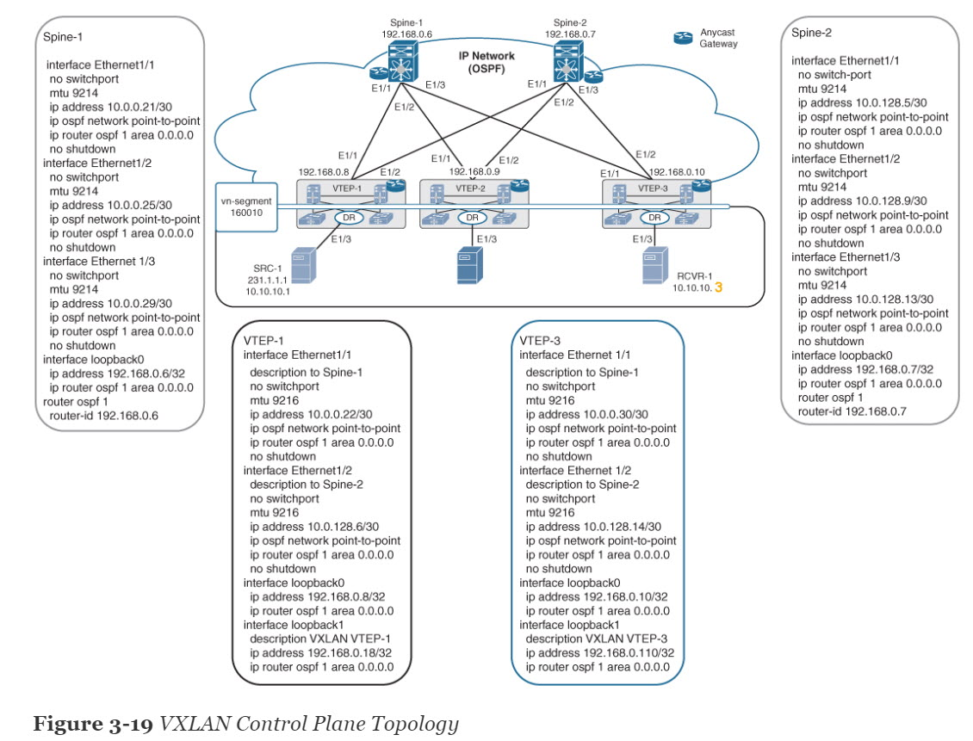

Page 186: The first paragraph from the top
186 | Ch 3, The first paragraph from the top:  Example 3-7 shows the spine router (Spine-1 and Spine-2) OSPF and multicast routing configuration, VTEP (VETP-1 and VTEP-3) multicast routing configuration, and multicast routing verification. | Should read:  Example 3-7 shows the spine router (Spine-1 and Spine-2) OSPF and multicast routing configuration, VTEP (VTEP-1 and VTEP-3) multicast routing configuration, and multicast routing verification.

Page 188-189: Example 3-7
188-189 | Ch 3, Example 3-7:  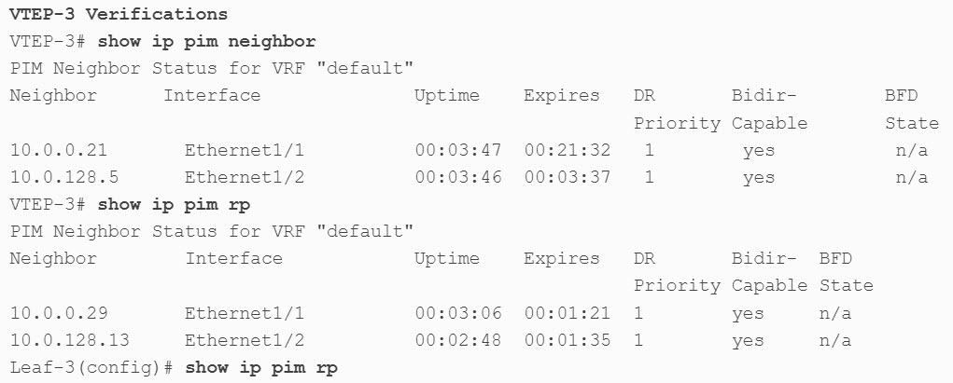 | Should read:  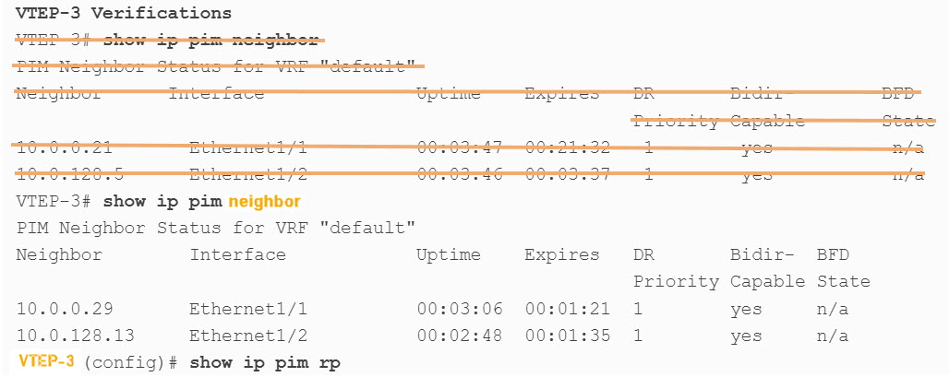

Chapter 4:

Page 194: The third paragraph from the top
Page 194 | Ch 4, The third paragraph from the top:  CH 4, Cisco ACI Initial Setup, Fabric Discovery, Access Policy, and  VMM Domains:  This section discusses ACI spin and leaf switch discovery, including ACI switch and interface policies. It also discusses how the  Virtual Machine Manager (VMM) supports integration with a multivendor hypervisor and provides a configuration example. | Should read:  Cisco ACI Initial Setup, Fabric Discovery, Access Policy, and  VMM Domains:  This section discusses ACI spine and leaf switch discovery, including ACI switch and interface policies. It also discusses how the Virtual Machine Manager (VMM) supports integration with a multi-vendor hypervisor and provides a configuration example.

Page 195: Ch4 Question 1

Page 195 | Ch 4, “DO I KNOW THIS ALREADY?” QUIZ  1. Which options outline the design requirements for spine nodes in a CLOS design? (Choose two answers.)  A. Host connectivity  B. High 40–100  C. GBps ports  D. Leaf-to-spine full-mesh interconnectivity  E. APIC-to-leaf interconnectivity | Should read:  1. Which options outline the design requirements for spine nodes in a CLOS design? (Choose two answers.)  A. Host connectivity  B. High 40–100 GBps ports  C. Leaf-to-spine full-mesh interconnectivity  D. APIC-to-leaf interconnectivity

Page 200: first paragraph from top

Page 200 | Ch 4, Page 200 first bullet:  decommission the affected leaf nodes from the APIC and register them again so that the inconsistency in the node IDs is resolved and the health status of the APICs in a cluster are in a fully fit state. | Should read:  decommission the affected leaf nodes from the APIC and register them again so that the inconsistency is in the node IDs is resolved and the health status of the APICs in a cluster are is in a fully fit state.

Page 201: first Paragraph from top

Page 201 | Ch 4, first Paragraph from top  Nexus 9000 configurations either can operate in Cisco NX-OS standalone mode for compatibility and consistency with the current Cisco Nexus switches | Should read:  Nexus 9000 configurations either can operate either in Cisco NX-OS standalone mode for compatibility and consistency with the current Cisco Nexus switches

Page 202: Fourth Paragraph from top

Page 202 | Ch 4, Fourth Paragraph from top  The Cisco Nexus 9000 product family consists of | Should read:  The Cisco Nexus 9000 product family consists of:

Page 205: The second paragraph from the bottom
205 | Ch 4, The second paragraph from the bottom:  Connecting the Cisco APIC to the Cisco ACI fabric requires a 10-GBps interface on the ACI-mode leaf switch. You cannot connect the Cisco APIC directly to the Cisco Nexus 9332PQ, Cisco Nexus 93180LC, or Cisco Nexus 9336C-FX2 ACI-mode leaf switches unless you use a 40 GBps-to-10 GBPs converter (part number CVR-QSFPSFP10G), in which case the port on the leaf switches will autonegotiate to GBps without requiring any manual configuration. | Should read:  Connecting the Cisco APIC to the Cisco ACI fabric requires a 10 Gbps interface on the ACI-mode leaf switch. You cannot connect the Cisco APIC directly to the Cisco Nexus 9332PQ, Cisco Nexus 93180LC, or Cisco Nexus 9336C-FX2 ACI-mode leaf switches unless you use a 40 Gbps-to-10 Gbps converter (part number CVR-QSFP-SFP10G), in which case the port on the leaf switches will autonegotiate to 10 Gbps without requiring any manual configuration.

Page 206: Table 4-2
206 | Ch 4, Table 4-2:  Blank boxes in Table 4-2 | Should read:  Fill blank boxes with hyphen “–“

Page 207: Table 4-2
207 | Ch 4, Table 4-2: | Should read:
  IPv4/IPv6 addresses  for  the out-of-band  management | IP address that  you use to access  the APIC through  the GUI, CLI, or  API. This address  must be a reserved  address from the  VRF of a customer.
  IPv4/IPv6 addresses  for  the out-of-band  management | IP address that  you use to access  the APIC through  the GUI, CLI, or  API. This address  must be a reserved  address from the  VRF of a customer.

209 | Ch 4, Table 4-3: | Should read:
  IPv4/IPv6 addresses  for  the out-of-band  management | IP address that  you use to access  the APIC through  the GUI, CLI, or  API. This address  must be a reserved address from the VRF of a customer.
  IPv4/IPv6 addresses  for  the out-of-band  management | IP address that  you use to access  the APIC through  the GUI, CLI, or  API. This address  must be a reserved address from the VRF of a customer.

Page 212: Second paragraph from top
Page 212 | Ch 4, Second paragraph from top  At a high level, the steps to upgrade or downgrade the Cisco ACI fabric are as follows. (The procedure or steps for upgrading and downgrading are | Should read:  At a high level, the steps to upgrade or downgrade the Cisco ACI fabric are as follows. (The procedure or steps for upgrading and downgrading are

Page 214: Virtual Routing and Forwarding Objects

Page 214 | Ch 4, Virtual Routing and Forwarding Objects  A Virtual Routing and Forwarding (VRF) object (fvCtx) or context is a tenant network (called a private network in the APIC GUI). A tenant can have multiple VRFs. | Should read:  A Virtual Routing and Forwarding (VRF) object (fvCtx) or context is a tenant network (called a private network in the APIC GUI) (IP address space). A tenant can have multiple VRFs.

Page 214: Bridge Domains and Subnets

Page 214 | Ch 4, Bridge Domains and Subnets  A bridge domain (BD) must be linked to a VRF (also known as a context or private network). With the exception of a Layer 2 VLAN, it must have at least one subnet associated with it. | Should read:  A bridge domain (BD) must be linked to a VRF (also known as a context or private network). With the exception of a Layer 2 VLAN, it must have at least one subnet associated with it.

Page 216: Attachable Entity Profile last paragraph

Page 216 | Ch 4, Attachable Entity Profile bulleted paragraph  ■ The AEP defines the range of allowed VLANS, but it does not provision them. No  traffic flows unless an EPG is deployed on the port. Without defining a VLAN pool in  an AEP, a VLAN is not enabled on the leaf port even if an EPG is provisioned.  ■ A particular VLAN is provisioned or enabled on the leaf port that is based on EPG events either statically binding on a leaf port or based on VM events from external controllers such as VMware vCenter or Microsoft Azure Service Center Virtual Machine Manager. | Should read:  ■ The AEP defines the range of allowed VLANs, but it does not provision them. No traffic flows unless an EPG is deployed on the port. Without defining a VLAN pool in an AEP, a VLAN is not enabled on the leaf port even if an EPG is provisioned.  ■ A particular VLAN is provisioned or enabled on the leaf port that is based on EPG events either statically binding on a leaf port on a leaf interface either through static port binding or based on VM events from external controllers such as VMware vCenter or Microsoft Azure Service Center Virtual Machine Manager.

Page 219: Figure 4-15
219 | Ch 4, Figure 4-15:  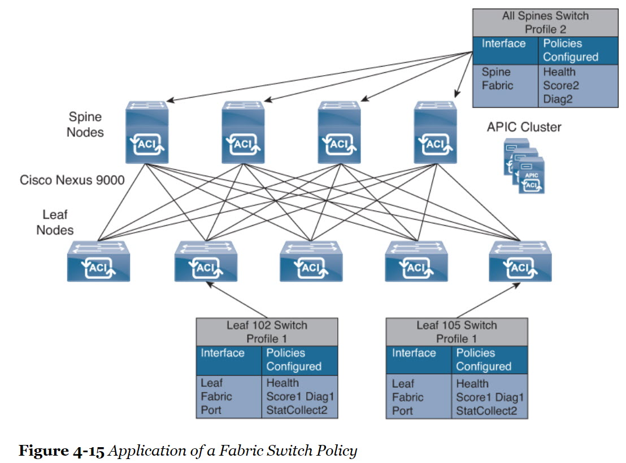 | Should read:  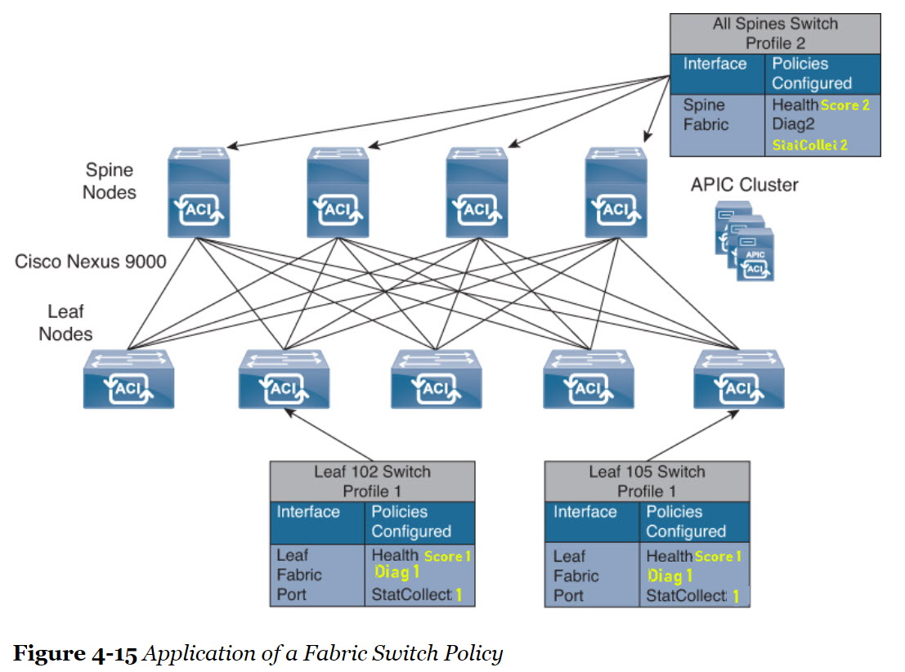

Page 226: Last paragraph after figure 4-23

Page 226 | Ch 4, Last paragraph after figure 4-23  As traffic enters the fabric, the ACI encapsulates and applies policy to it, forwards it as needed across the fabric through a spine switch (maximum two-hops), and deencapsulates it upon exiting the fabric. | Should read:  As traffic enters the fabric, the ACI encapsulates and applies policy to it, forwards it as needed across the fabric through a spine switch (maximum two-hops), and deencapsulates it upon exiting the fabric.

Page 227: Cisco ACI Tenants

Page 227 | Ch 4, Cisco ACI Tenants  Tenant networking is used to define networking policies and will be applied to the underlying hardware in a transparent way thanks to the layer of abstraction provided by ACI using private networks, bridge domains, and subnets. | Should read:  Tenant networking is used to define networking policies and will be applied to the underlying hardware in a transparent way thanks to the layer of abstraction provided by ACI using VRFs private networks, bridge domains, and subnets.
Page 227 | Ch 4, Cisco ACI Tenants  1. Common: This special tenant has unique abilities to easily share its resources with other tenants, with the purpose of providing “common” services to other tenants in the ACI fabric. Global reuse is a core principle in the common tenant. Some examples of common services are  - Shared L3 out  - Shared private networks  - Shared bridge domains | Should read:  1. Common: This special tenant has unique abilities to easily share its resources with other tenants, with the purpose of providing “common” services to other tenants in the ACI fabric. Global reuse is a core principle in the common tenant. Some examples of common services are  - Shared L3 out  - Shared VRFs private networks  - Shared bridge domains

Page 228:

Page 228 | Ch 4, second paragraph from top  2. Infra: This infrastructure tenant is used for all internal fabric communications, such as tunnels and policy deployment. This includes switch-to-switch (leaf, spine, Application Virtual Switch) and switch-to-Application Policy Infrastructure Controller. The infra tenant does not get exposed to the user space (tenants), and it has its own private network space and bridge domains. Fabric discovery, image management, and DHCP for fabric functions are all handled within this tenant. | Should read:  2. Infra: This infrastructure tenant is used for all internal fabric communications, such as tunnels and policy deployment. This includes switch-to-switch (leaf, spine, Application Virtual Switch) and switch-to-Application Policy Infrastructure Controller communications. The infra tenant does not get exposed to the user space (tenants), and it has its own private network space (VRF) and bridge domains. Fabric discovery, image management, and DHCP for fabric functions are all handled within this tenant.
Page 228 | Ch 4, Virtual Routing and Forwarding  Virtual Routing and Forwarding (VRF)—also known as private network, private Layer 3 network, or context—is a unique Layer 3 forwarding and application policy domain. Private networks are a child of the tenant object. All of the endpoints within the private network must have unique IP addresses because it is possible to forward packets directly between these devices if the policy allows it. One or more bridge domains are associated with a private network.  The most common method to share private networks between tenants is through the common tenant. Private networks created in the common tenant are shared globally within the fabric. However, a private network that is intended to be used by multiple tenants and is not created in the common tenant requires explicit configuration to be shared. | Should read:  Virtual Routing and Forwarding (VRF)—also known as private network, private Layer 3 network, or context—is a unique Layer 3 forwarding and application policy domain. Private networks VRFs are a child of the tenant object. All of the endpoints within the VRF private network must have unique IP addresses because it is possible to forward packets directly between these devices if the policy allows it. One or more bridge domains are associated with a VRF private network.  The most common method to share VRFs private networks between tenants is through the common tenant. VRFs Private networks created in the common tenant are shared globally within the fabric. However, a VRF private network that is intended to be used by multiple tenants and is not created in the common tenant requires explicit configuration to be shared.

Page 229: Bridge Domain and Subnets

Page 229 | Ch 4, Bridge Domain and Subnets  A bridge domain (fvBD) is the logical representation of a Layer 2 forwarding  domain within the fabric. A bridge domain is a child of the tenant object and must be linked to a private network.  The bridge domain defines the unique Layer 2 MAC address space and a Layer 2 flood domain if flooding is enabled. While a private network defines a unique IP address space, that address space can consist of multiple subnets. Those subnets will be spread across one or more bridge domains  contained in the private network.  Bridge domains will span all switches in which associated endpoint groups are configured. A bridge domain can have multiple subnets. However, a subnet is contained within a single bridge domain.  Figure 4-25 provides an example of a tenant that shows how bridge domains are contained inside of private networks and how they are linked to endpoint groups and the other elements. | Should read:  A bridge domain (fvBD) is the logical representation of a Layer 2 forwarding  domain within the fabric. A bridge domain is a child of the tenant object and must be linked to a VRF private network.  The bridge domain defines the unique Layer 2 MAC address space and a Layer 2 flood domain if flooding is enabled. While a VRF private network defines a unique IP address space, that address space can consist of multiple subnets. Those subnets will be spread across one or more bridge domains contained in the VRF private network.  Bridge domains will span all switches in which associated endpoint groups are configured. A bridge domain can have multiple subnets. However, a subnet is contained within a single bridge domain.  Figure 4-25 provides an example of a tenant that shows how bridge domains are contained inside of VRFs private networks and how they are linked to endpoint groups and the other elements.

Page 229: Figure 4-25

Page 229 | Ch 4, Figure 4-25  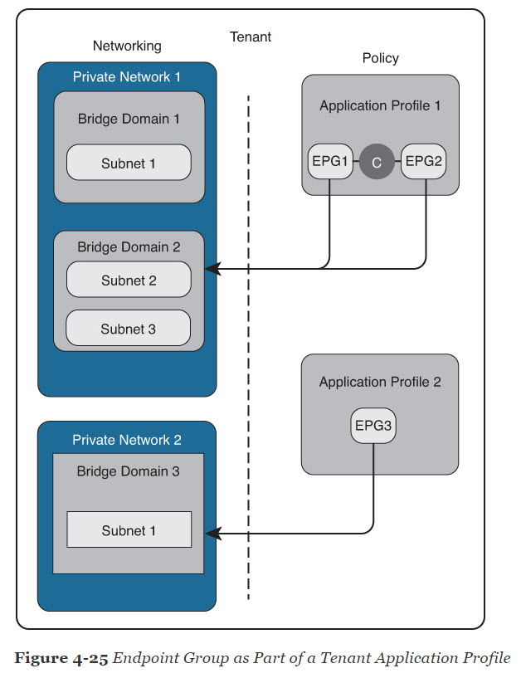 | Should read:  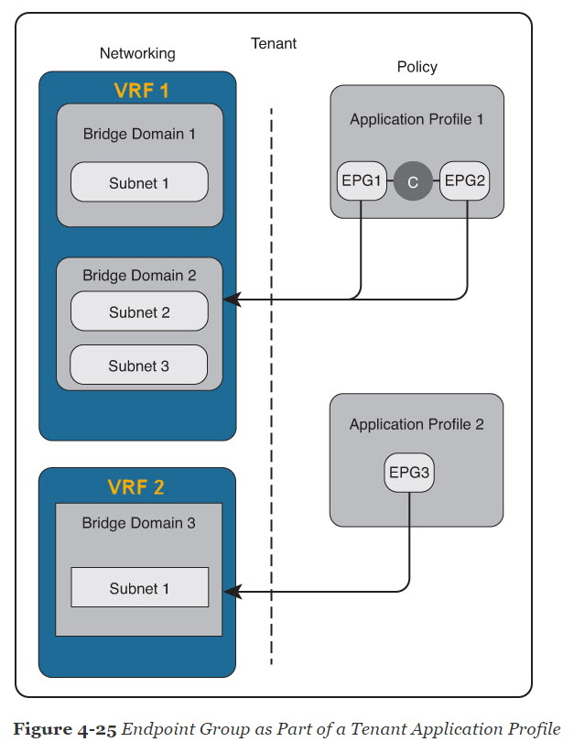

Page 230: The fourth Paragraph from top

Page 230 | Ch 4, The fourth Paragraph from top  Endpoint groups are also assigned with a PI VLAN ID that is locally significant in each leaf. This VLAN ID is different from the bridge domain. Therefore, in the Cisco ACI, several VLANs are used for endpoints inside on one bridge domain. | Should read:  Endpoint groups are also assigned with a PI VLAN ID that is locally significant in each leaf. This VLAN ID is different from the bridge domain. Therefore, in the Cisco ACI, several VLANs are used for endpoints inside on one bridge domain.

Page 233: The third paragraph from the top
233 | Ch 4, The third paragraph from the top:  Taboo contracts are used to deny and log traffic related to regular contracts and are configured into the hardware before the regular contract. For example, if the objective is to allow traffic with source ports 20 through 1200 with the exception of port 45, then the regular contract would allow all ports in the range of 50 through 500 while the taboo contract would have a single entry denying port 45. | Should read:  Taboo contracts are used to deny and log traffic related to regular contracts and are configured into the hardware before the regular contract. For example, if the objective is to allow traffic with source ports 20 through 1200 with the exception of port 45, then the regular contract would allow all ports in the range of 20 through 1200 while the taboo contract would have a single entry denying port 45.

Page 237: At the middle of the page

Page 237 | Ch 4, At the middle of the page  ■ Filters are Layer 2 to Layer 4 fields, TCP/IP header fields such as Layer 3 protocol  type, Layer 4 ports, and so forth. According to its related contract, an EPG provider  dictates the protocols and ports in both the in and out directions. Contract subjects  contain associations to the filters (and their directions) that are applied between EPGs  that produce and consume the contract.  ■ Subjects are contained in contracts. One or more subjects within a contract use  filters to specify the type of traffic that can be communicated and how it occurs.  For example, for HTTPS messages, the subject specifies the direction and the  filters that specify the IP address type (for example, IPv4), the HTTP protocol, and  the ports allowed. | Should read:  ■ Filters are Layer 2 to Layer 4 fields, TCP/IP header fields such as Layer 3 protocol  type, Layer 4 ports, and so forth. According to its related contract, an EPG provider  dictates the protocols and ports in both the in and out directions. Contract subjects  contain associations to the filters (and their directions) that are applied between EPGs  that produce provide and consume the contract.  ■ Subjects are contained in contracts. One or more subjects within a contract use  filters to specify the type of traffic that can be communicated and how it occurs.  For example, for HTTPS messages, the subject specifies the direction and the  filters that specify the IP address type (for example, IPv4), the HTTP TCP protocol, and  the ports allowed.

Page 239: Third paragraph from the top

Page 239 | Ch 4, Third paragraph from the top  For security reasons, some service providers restricted out-of-band connectivity to local connections. Others can choose to enable routed or bridged connections from external networks. | Should read:  For security reasons, some service providers restricted out-of-band connectivity to local connections. Others can choose to enable routed or bridged connections from external networks.

Page 243: ACI Fabric Traffic Storm Control second paragraph

Page 243 | Ch 4, ACI Fabric Traff ic Storm Control second paragraph  By default, storm control is not enabled in the ACI fabric. The ACI bridge domain Layer 2 unknown unicast flooding is enabled by default within the BD but can be disabled by an administrator. In that case, a storm control policy applies only to broadcast and unknown multicast traffic. If Layer 2 unknown unicast flooding is enabled in a BD, a storm control policy applies to Layer 2 unknown unicast flooding in addition to broadcast and unknown multicast traffic. | Should read:  By default, storm control is not enabled in the ACI fabric. The ACI bridge domain Layer 2 unknown unicast flooding is enabled by default within the BD but can be disabled by an administrator. In that case, a storm control policy applies only to broadcast and unknown multicast traffic. If Layer 2 unknown unicast flooding is enabled in a BD, a storm control policy applies to Layer 2 unknown unicast flooding in addition to broadcast and unknown multicast traffic.  By default, storm control is not enabled in the ACI fabric. ACI bridge domain Layer 2 unknown unicast flooding is disabled by default within the BD but can be enabled by an administrator. If disabled (default), the storm control policy applies only to broadcast and unknown multicast traffic. If Layer 2 unknown unicast flooding is enabled in a BD, then the storm control policy applies to Layer 2 unknown unicast flooding in addition to broadcast and unknown multicast traffic.

Page 244: First Paragraph at the top

Page 244 | Ch 4, First Paragraph at the top  used in networks where each flow is allocated to an uplink based on a hash of its 5-tuple. This load balancing gives a distribution of flows across the available links that is roughly even. Usually, with a large number of flows, the even distribution of flows results in an even distribution of bandwidth as well. However, if a few flows are much larger than the rest, static load balancing might give suboptimal results. | Should read:  used in networks where each flow is allocated to an uplink based on a hash of its 5-tuple.This load balancing gives a distribution of flows across the available links that is roughly even This load balancing spreads the flows across the available links in a fairly even fashion. Usually, with a large number of flows, the even distribution of flows results in an even distribution of bandwidth as well. However, if a few flows are much larger than the rest, static load balancing might give lead to suboptimal results.

Page 245: ACI LAB Configurations Example
245 | Ch 4, ACI LAB Configurations Example  Figures 4-39 to 4-62 | Should read:  Please see updated high resolution images in the zip file named “Ch 4 High Resolution Images.zip” attached.  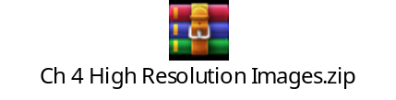

Page 248: Second Paragraph from top

248 | Ch 4, Second Paragraph from top  Step 2. Verify the fabric inventory by choosing Fabric > Fabric Policies > Fabric Membership, as shown in Figure 4-40. | Should read:  Step 2. Verify the fabric inventory by choosing Fabric > Fabric Policies Inventory > Fabric Membership, as shown in Figure 4-40.

Page 251:

251 | Ch 4, First Paragraph from bottom  Creating Tenant  Creating a tenant requires you to create a VRF and bridge domain. In this example, you first create a tenant named ACILab and then can create a VRF named ACILab_DCCOR that has two bridges: ACILab_BD_DCCOR_1 and ACILab_BD2_DCCOR_1. | Should read:  Creating Tenant  Creating a tenant requires you to create a VRF and bridge domain. In this example, you first create a tenant named ACILab and then can create a VRF named ACILab_DCCOR that has two bridges: ACILab_BD_DCCOR_1 and ACILab_BD2_DCCOR_12.

Page 253: First Paragraph from bottom

253 | Ch 4, First Paragraph from bottom  To create a second bridge domain and add it to the same VRF, right-click Bridge Domains and click + (the plus sign). The Create Bridge Domain page opens with the three steps shown in Figure 4-47. | Should read:  To create a second bridge domain and add it to the same VRF, right-click Bridge Domains and click + (the plus sign) Create Bridge Domain. The Create Bridge Domain page opens with three four steps shown in Figure 4-47.

Page 254: First Paragraph from top
254 | Ch 4, First paragraph from top  Step 5. After creating the VRF and two BDs, verify the tenant network topology by selecting Tenant ACILab > Networking, as shown in Figure 4-48. | Should Read  Step 5. After creating the VRF and two BDs, verify the tenant network topology by selecting Tenant > Specific Tenant (ACILab) > Networking, as shown in Figure 4-48.

Page 254: Second Paragraph from top

254 | Ch 4, Second paragraph from top  Create a filter that passes only HTTP traffic between the consumer and provider. To do so, choose Tenants > ACILab Tenant > Contracts. Then right-click Filter (see Figure 4-49). | Should Read  Create a filter that passes only HTTPS traffic between the consumer and provider. To do so, choose Tenants > Specific Tenant (ACILab) > Contracts. Then right-click Filter and select Create Filter (see Figure 4-49).

Page 255:

255 | Ch 4, Second paragraph from top  Step 2. Specify the filter name and click + (the plus sign) to add the ACL. The ACL has a protocol type (IP/TCP), source ports, and destination ports. For HTTPS, the protocol is TCP/IP, the source ports are any, and the destination ports are 443/443, as shown in Figure 4-50. | Should Read  Step 2. Specify the filter name and click + (the plus sign) to add the ACLfilter. The ACLfilter has a protocol type (IP/TCP) Ether Type and IP Protocol type, source ports, and destination ports. For HTTPS, the Ether type is IP and the IP protocol is TCP/IP, the source ports are any, and the destination ports are https/https, as shown in Figure 4-50.

Page 256: Figure 4-51

256 | Ch 4, Figure 4-51  Figure 4-51 Creating More HTTPS Filters | Should Read  Figure 4-51 Creating More HTTPS Filters

Page 259: First Paragraph from top

259 | Ch 4, First Paragraph from top  Step 1. Choose VM Networking > VMM Domains > VMware; then click + (the plus sign) to add a new vCenter, as shown in Figure 4-57. | Should Read  Step 1. Choose VM Virtual Networking > VMM Domains > VMware; then click + (the plus sign) to add a new vCenter domain, as shown in Figure 4-57.

Page 260: First Paragraph from top

260 | Ch 4, First Paragraph from top  Step 4. Select a vCenter IP address, distributed virtual switch type, and data center  name so that the APIC can connect to the vCenter, as shown in Figure 4-60. | Should Read  Step 4. Select Enter a vCenter IP address or host name, distributed virtual switch type, and data center  name so that the APIC can connect to the vCenter, as shown in Figure 4-60.

Chapter 6:
Page 281: Step 5.
281 | Ch 6, Step 5.  Enter the user role (network-operator|network-you)  [network-operator]: default_user_role | Should read:  Enter the user role (network-operator|network-admin)  [network-operator]: default_user_role

Page 284: Figure 6-3
284 | Ch 6, Figure 6-3:  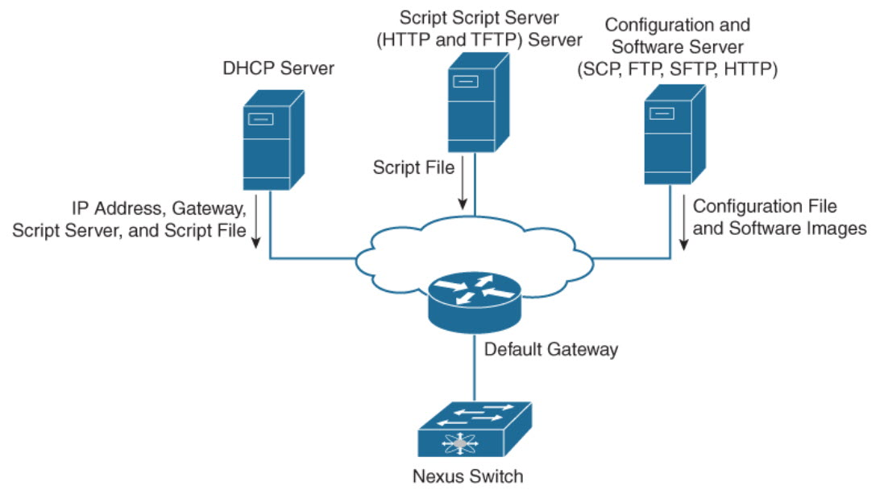  Script Script Server  (HTTP and TFTP) Server | Should read:  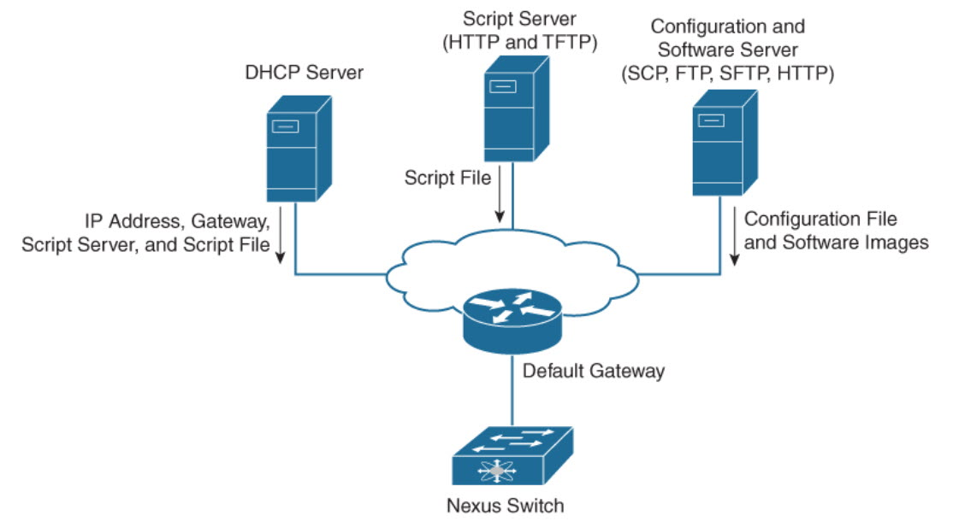  Correction in Image: Script Script Server  (HTTP and TFTP) Server

Page 288:
288 | Ch 6, Step 4.  switch# install activate n7700-s2- dk9.7.2.0.D1.1.CSCuo07721.bin | Should read:  switch# install activate n7700-s2-dk9.7.2.0.D1.1.CSCuo07721.bin  Remove the space between s2- and dk9
288 | Ch 6, Step 5.  System Image: bootflash:/ n7700-s2-dk9.7.2.0.D1.1.bin | Should read:  System Image: bootflash:/n7700-s2-dk9.7.2.0.D1.1.bin  Remove the space between / and n7700

Page 294:
294 | Ch 6, Example 6-4:  config-profile maintenance-mode type you | Should read:  config-profile maintenance-mode type admin
294 | Ch 6, Example 6-5:  config-profile normal-mode type you | Should read:  config-profile normal-mode type admin

Page 304: Third paragraph from end of page.
304 | Page 304: Third paragraph from end of page.  To create a checkpoint named chk, you can verify the difference and rollback by skipping any errors: | Should read:  To create a checkpoint named chk, you can verify the difference and rollback by skipping any errors:  After creating a checkpoint, you can verify the difference between the checkpoint and the running-config(if you made any changes to running-config) and rollback by skipping any errors.

Page 305: Step 4.
305 | Ch 6, Step 4.  !!  interface Ethernet2/2  no shutdown  exit | Should read:  !!  interface Ethernet2/1  no shutdown  exit

Page 322: Table 6-13
322 | Ch 6, Table 6-13:  IF-MIB  snmp-server enable traps link linkDown  snmp-server enable traps link Up | Should read:  IF-MIB  snmp-server enable traps link linkDown  snmp-server enable traps link linkUp

Page 323: Table 6-15
323 | Ch 6, Table 6-15: | Should read:  Delete Duplicate entry in same table.
  show running-config snmp [ all ] | Displays the SNMP running configuration.
  show running-config snmp [ all ] | Displays the SNMP running configuration.

Page 332: Example 6-22
332 | Ch 6, Example 6-22:  switch(config-monitor)# source interface ethernet 3/11 both | Should read:  switch-1(config-monitor)# source interface ethernet 3/11 both
332 | Ch 6, Example 6-22:  switch7000-1(config-monitor)# destination interface ethernet 3/48 | Should read:  switch-1(config-monitor)# destination interface ethernet 3/48
332 | Ch 6, Example 6-22:  switch7000-1(config-monitor)# no shut  switch7000-1(config-monitor)# exit | Should read:  switch-1(config-monitor)# no shut  switch-1(config-monitor)# exit

Page 333: The eighth paragraph from the top
333 | Ch 6, The eighth paragraph from the top:  ERSPAN consists of an ERSPAN source session, routable ERSPAN GRE-encapsulated traffic, and an ERSPAN destination session. | Should read:  ERSPAN consists of an ERSPAN source session, routable ERSPAN GRE-encapsulated traffic, and an ERSPAN destination session.  Remove Duplicate paragraph.

Page 334: The first paragraph from the top
334 | Ch 6, The first paragraph from the top:  Example 6-24 shows an ERSPAN source switch configuration, SPAN source port (interface E2/10), and destination session (IP address 11.11.11.3/32). | Should read:  Example 6-24 shows an ERSPAN source switch configuration, SPAN source port (interface E2/10), and destination session (IP address 10.11.11.3).

Page 335:
335 | Ch 6, The first paragraph from the top:  Example 6-25 shows an ERSPAN destination switch configuration, SPAN destination port (interface E2/34), and source session (address 10.11.11.3/32). | Should read:  Example 6-25 shows an ERSPAN destination switch configuration, SPAN destination port (interface E2/34), and source session (IP address 10.11.11.3).

Page 336: Example 6-26
336 | Ch 6, Example 6-26:  switch_1# show monitor  Session State Reason Description  ------- ------- ----------- -----------------------  4 up The session is up | Should read:  switch_1# show monitor  Session State Reason Description  ------- ------- ----------- -----------------------  48 up The session is up

Page 339: Example 6-27
339 | Ch 6, Example 6-27:  switch(conf-tm-dest)# sensor-group 1  switch(conf-tm-sensor# data-source NX-API | Should read:  switch(conf-tm-dest)# sensor-group 1  switch(conf-tm-sensor)# data-source NX-API

Chapter 11
Page 514: Cisco UCS Overview
514 | Ch 11, Cisco UCS Overview  Cisco UCS Initial Setup and Management: This section cover UCS B-Series and C-Series initial setup and configuration. | Should read:  Cisco UCS Initial Setup and Management: This section covers UCS B-Series and C-Series initial setup and configuration.
514 | Ch 11, key topics list  UCS Storage Management: This section discusses UCS SAN management, including SAN connectivity (iSCSI, Fibre Channel, FCoE), VSANs, WWN pools, and zoning. | Should read:  UCS Storage Management: This section discusses UCS SAN management, including SAN connectivity (iSCSI, Fibre Channel, FCoE), VSANs, WWN pools, and zoning.
514 | Ch 11, Table 11-1  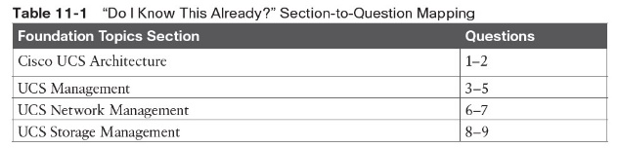 | Should read:  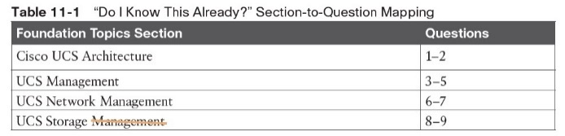

Page 515: Ch 11, Q1 self-assessment

515 | Ch 11, Q2 self-assessment  2. What type of connection does UCS blade chassis FEX fabric support? (Choose two answers.)  a. Basic mode  b. Discrete mode  c. Port mode  d. Port channel mode | Should read:  2. What type of connections does UCS blade chassis FEX fabric support? (Choose two answers.)  a. Basic mode  b. Discrete mode  c. Port mode  d. Port channel mode

Page: 516 Ch 11, Q6 self-assessment

516 | Ch 11, Q6 self-assessment  6. If the virtual local-area network (VLAN) is deleted from the fabric interconnect using the Cisco UCS Manager, what happens? | Should read:  6. If the virtual local area network (VLAN) is deleted from the fabric interconnect using the Cisco UCS Manager, what happens?
516 | Ch 11, Q8 self-assessment  8. Which method is a TCP/IP-based protocol for establishing and managing connections between IP-based storage devices, hosts, and clients?  a. iFCP  b. FCIP  c. iSCSI  d. FCoE | Should read:  8. Which method is a TCP/IP-based protocol for establishing and managing connections between IP-based storage devices, hosts, and clients storage communication is supported by the Cisco UCS?  a. iFCP  b. FCIP  c. iSCSI  d. FCoE
516 | Ch 11, Q9 self-assessment  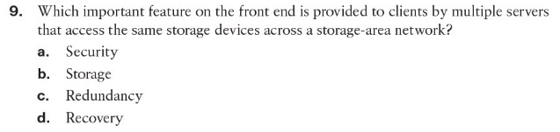 | Should read:  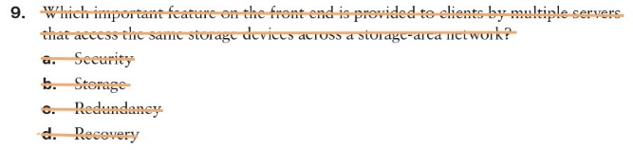  9. What type of UCS network storage provides maximum reliability, expandability, and performance?  a. Network-attached storage (NAS).  b. Direct-attached storage (DAS).  c. RAID storage.  d. Storage-area network (SAN).

Page 519: Ch 11 First paragraph from bottom
519 | Ch 11, First paragraph from bottom  - Cisco UCS Mini solutions: These solutions can be created by using Cisco UCS 6234 Fabric Interconnects in the blade server chassis instead of rack-mount FEXs. | Should read:  - Cisco UCS Mini solutions: These solutions can be created by using Cisco UCS 6324 Fabric Interconnects in the blade server chassis instead of rack-mount FEXs.

Page 520: Ch 11 First paragraph from bottom

520 | Ch 11, First paragraph from bottom  Cisco UCS B480 M5 is a full-width server that uses second-generation Intel Xeon Scalable processors or Intel Xeon Scalable processors with up to 6 TB of memory or 12 TB of Intel Optane DC persistent memory; up to four SAS, SATA, and NVMe drives; M.2 storage; up to four GPUs; and 160-Gigabit Ethernet connectivity. It offers exceptional levels of performance, flexibility, and I/O throughput to run the most demanding applications. | Should read:  Cisco UCS B480 M5 is a full-width server that uses second-generation Intel Xeon Scalable processors or Intel Xeon Scalable processors with up to 12 TB of memory, or up to 18 TB of Intel Optane DC persistent memory; up to four SAS, SATA, and NVMe drives; M.2 storage; up to four GPUs; and 160-Gigabit Ethernet connectivity. It offers exceptional levels of performance, flexibility, and I/O throughput to run the most demanding applications.

Page 523: Ch 11 Third paragraph from top

523 | Ch 11 Third paragraph from top  In the Cisco UCS Mini solution, the Cisco UCS 6324 Fabric Interconnect is collapsed into the I/O module form factor and is inserted into the IOM slot of the blade server chassis. The Cisco UCS 6324 Fabric Interconnect has 24 × 10G ports available on it. Sixteen of these ports are server facing, and two 10G ports are dedicated to each of the eight half-width blade slots. | Should read:  In the Cisco UCS Mini solution, the Cisco UCS 6324 Fabric Interconnect is collapsed into the I/O module form factor and is inserted into the IOM slot of the blade server chassis. The Cisco UCS 6324 Fabric Interconnect has 24 x 10G ports available on it. Sixteen of these ports are server facing, and providing two 10G dedicated ports are dedicated to each of the eight half-width blade slots.

Page 524: Cisco UCS Fabric Infrastructure
524 | Ch 11, Cisco UCS Fabric Infrastructure  The following fabric interconnects are available in the Cisco UCS Fabric Interconnects product family:  - Cisco UCS 6454 Fabric Interconnects  - Cisco UCS 6300 Series Fabric Interconnects  - Cisco UCS 6200 Series Fabric Interconnects  - Cisco UCS 6324 Fabric Interconnects | The following fabric interconnects are available in the Cisco UCS Fabric Interconnects product family:  ■ Cisco UCS 6454 6400 Series Fabric Interconnects (Models: 6454, 64108)  ■ Cisco UCS 6300 Series Fabric Interconnects (Models: 6332, 6332-16UP and 6324)  ■ Cisco UCS 6200 Series Fabric Interconnects (Models: 6248UP and 6296UP)  ■ Cisco UCS 6324 Fabric Interconnects

Page 524: Fourth paragraph from the top

524 | Ch 11, Fourth paragraph from the top  It has 48 10/25-Gigabit Ethernet SFP28 ports (16 unified ports) and 6 40/100-Gigabit Ethernet QSFP28 ports. Each 40/100-Gigabit Ethernet port can break out into 4 × 10/25-Gigabit Ethernet uplink ports. The 16 unified ports support 10/25-Gigabit Ethernet or 8/16/32-Gbps Fibre Channel speeds. | Should read:  It has 44 10/25-Gigabit Ethernet SFP28 ports (16 unified ports), 4 1/10/25-Gigabit Ethernet ports and 6 40/100-Gigabit Ethernet QSFP28 ports. Each 40/100-Gigabit Ethernet port can break out into 4 × 10/25-Gigabit Ethernet uplink ports. The 16 unified ports support 10/25-Gigabit Ethernet or 8/16/32-Gbps Fibre Channel speeds.

Page 524: Second paragraph from top

531 | Ch 11, Second paragraph from top  Cisco UCS Manager single-wire management supports an additional option to integrate the C-Series rack-mount server with the Cisco UCS Manager using the NC-SI. | Should read:  Cisco UCS Manager single-wire management supports an additional option to integrate the C-Series rack-mount server with the Cisco UCS Manager using the Network Controller Sideband Interface (NC-SI).

Page 544: First paragraph from top

544 | Ch 11, First paragraph from top  A fully redundant Cisco Unified Computing System consists of two independent fabric planes: Fabric A and Fabric B. Each plane consists of a central fabric interconnect (Cisco UCS 6300 or 6200 Series Fabric Interconnects) connected to an I/O module (Fabric Extender) in each blade chassis. | Should read:  A fully redundant Cisco Unified Computing System consists of two independent fabric planes: Fabric A and Fabric B. Each plane consists of a central fabric interconnect (Cisco UCS 6300 or 6200 Series Fabric Interconnects) connected to an I/O module (Fabric Extender) in each blade chassis.

Page 547: Second paragraph from top

547 | Ch 11, Second paragraph from top  Changing the port mode deletes the existing port configuration and replaces it with a new logical port. Any objects associated with that port configuration, such as VLANs and VSANS, are also removed. There is no restriction on the number of times you can change the port mode for a unified port. | Should read:  Changing the port mode deletes the existing port configuration and replaces it with a new logical port. Any objects associated with that port configuration, such as VLANs and VSANs, are also removed. There is no restriction on the number of times you can change the port mode for a unified port.

Page 547: Third paragraph from top

547 | Ch 11, Third paragraph from top  When you set the port mode to Ethernet, you can configure the following Ethernet port types:  - Server ports  - Ethernet uplink ports  - Ethernet port channel members  - Appliance ports  - Appliance port channel members  - SPAN destination ports  - SPAN source ports | Should read:  When you set the port mode to Ethernet, you can configure the following Ethernet port types:  - Server ports  - Ethernet uplink ports  - Ethernet port channel members  - FCoE ports  - Appliance ports  - Appliance port channel members  - SPAN destination ports  - SPAN source ports

Page 566: Second paragraph from bottom

566 | Ch 11, Second paragraph from top  You can create more than one named VLAN with the same VLAN ID. For example, if servers that host business services for Human Resources and Finance need to access the same external LAN, you can create VLANs named HR and Finance with the same VLAN ID. Then, if the network is reconfigured and Finance is assigned to a different LAN, you only have to change the VLAN ID for the named VLAN for Finance. | Should read:  You can create more than one named VLAN with the same VLAN ID. For example, if servers that host business services for Human Resources and Finance need to access the same external LAN, you can create VLANs named HR and Finance with the same VLAN ID. Then, if the network is reconfigured and Finance is assigned to a different LAN, you only have to change the VLAN ID for the named VLAN for Finance. The VLAN name is case sensitive.

566 | Ch 11, Second paragraph from bottom  The VLAN name is case sensitive. The following types of ports are counted in the VLAN port calculation: | Should read:  The VLAN name is case sensitive. The following types of ports are counted in the VLAN port calculation:

Page 576: Server Pools

576 | Ch 11, Server Pools  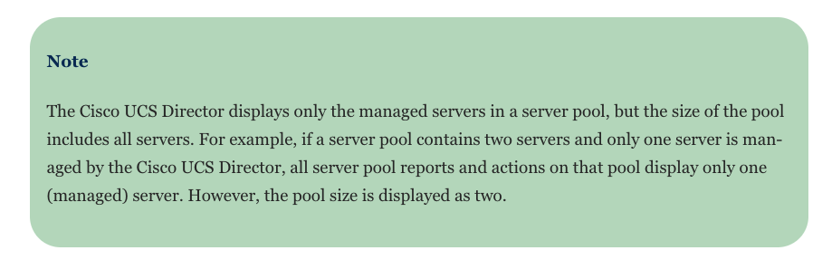  An example of creating a server pool is as follows:  Step 1. On the menu bar, choose Physical > Compute.  Step 2. In the left pane, expand the pod and then click the Cisco UCS Manager account.  Step 3. In the right pane, click the Organizations tab.  Step 4. Click the organization in which you want to create the pool and then click View Details.  Step 5. Click the Server Pools tab and then click Add.  Step 6. In the Add Server Pool dialog box, add a name and description for the pool.  Step 7. (Optional) In the Servers field, do the following to add servers to the pool:  ■ Click Select.  ■ On the Select Items page, click the check boxes for the servers that you want to add to the pool.  ■ Click Select.  Step 8. Click Add.  The following steps show how to assign a server pool to a Cisco UCS Director Group:  Step 1. On the menu bar, choose Physical > Compute.  Step 2. In the left pane, expand the pod and then click the Cisco UCS Manager account.  Step 3. In the right pane, click the Organizations tab.  Step 4. Click the organization that contains the pool you want to assign, and then click  View Details.  Step 5. Click the Server Pools tab.  Step 6. Click the row in the table for the pool that you want to assign to a Cisco UCS Director group.  Step 7. Click Assign Group.  Step 8. In the Select Group dialog box, do the following:  ■ From the Group drop-down list, choose the Cisco UCS Director group to which you want to assign this server pool.  ■ In the Label field, enter a label to identify this server pool.  ■ Click Submit. | Should read:  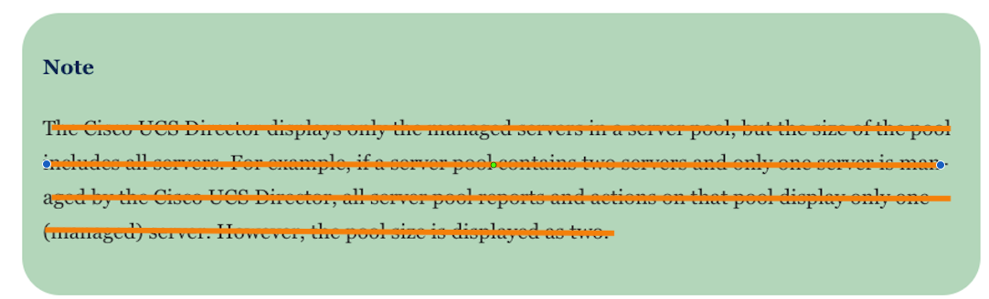  An example of creating a server pool is as follows:  Step 1. On the menu bar, choose Physical > Compute.  Step 2. In the left pane, expand the pod and then click the Cisco UCS Manager account.  Step 3. In the right pane, click the Organizations tab.  Step 4. Click the organization in which you want to create the pool and then click View Details.  Step 5. Click the Server Pools tab and then click Add.  Step 6. In the Add Server Pool dialog box, add a name and description for the pool.  Step 7. (Optional) In the Servers field, do the following to add servers to the pool:  ■ Click Select.  ■ On the Select Items page, click the check boxes for the servers that you want to add to the pool.  ■ Click Select.  Step 8. Click Add.  The following steps show how to assign a server pool to a Cisco UCS Director Group:  Step 1. On the menu bar, choose Physical > Compute.  Step 2. In the left pane, expand the pod and then click the Cisco UCS Manager account.  Step 3. In the right pane, click the Organizations tab.  Step 4. Click the organization that contains the pool you want to assign, and then click  View Details.  Step 5. Click the Server Pools tab.  Step 6. Click the row in the table for the pool that you want to assign to a Cisco UCS Director group.  Step 7. Click Assign Group.  Step 8. In the Select Group dialog box, do the following:  ■ From the Group drop-down list, choose the Cisco UCS Director group to which you want to assign this server pool.  ■ In the Label field, enter a label to identify this server pool.  ■ Click Submit.  An example of creating a server pool using Cisco UCS Manager is as follows:  Step 1 In the Navigation pane, click Servers.  Step 2 Expand Servers > Pools.  Step 3 Expand the node for the organization where you want to create the pool. If the system does not include multitenancy, expand the root node.  Step 4 Right-click the Server Pools node and select Create Server Pool.  Step 5 On the Set Name and Description page of the Create Server Pool wizard, complete the following fields:  Step 6 Click Next.  Step 7 On the Add Servers page of the Create Server Pool wizard:  - Select one or more servers from the Available Servers table.  - Click the >> button to add the servers to the server pool.  - When you have added all desired servers to the pool, click Finish.
  Name | Description
  Name field | The name of the server pool.
  Description field | A user-defined description of the server pool.

Page 584: First paragraph from top

584 | Ch 11, Second paragraph from top  Service profile templates created in Cisco UCS Central can be used on any of your registered Cisco UCS domains. The following steps show how to create a service profile template:  Step 1. In the Navigation pane, click the Servers tab.  Step 2. On the Servers tab, expand Servers > Service Profiles.  Step 3. Expand the node for the organization where you want to create the service profile. If the system does not include multitenancy, expand the root node.  Step 4. Right-click the organization and select Create Service Profile (Expert), as shown in Figure 11-48.  Step 5. In the Create Service Profile (expert) wizard, complete the following:  ■ Page 1: Identifying the Service Profile, as in Figure 11-49. | Should read:  Service profile templates created in Cisco UCS Central can be used on any of your registered Cisco UCS domains. The following steps show how to create a service profile template:  Step 1. In the Navigation pane, click the Servers tab.  Step 2. Expand Servers > Service Profiles Templates.  Step 3. Expand the node for the organization where you want to create the service profile template. If the system does not include multitenancy, expand the root node.  Step 4. Right-click the organization and select Create Service Profile Template(Expert), as shown in Figure 11-48.  Step 5. In the Create Service Profile (expert) Template wizard, complete the following:  ■ Page 1: Identifying the Service Profile Template, as in Figure 11-49.

Chapter 12
Page 611: “Do I Know This Already” quiz
611 | Ch 12, “Do I Know This Already” quiz  1. What types of UCS interfaces support traffic monitoring?  (Choose two answers.)  a. Ethernet  b. vNIC  c. Fiber Channel  d. FCoE Port | Should read:  1. What types of UCS interfaces support destination traffic monitoring?  (Choose two answers.)  a. Ethernet  b. vNIC  c. Fiber Channel  d. FCoE Port
611 | Ch 12, initial quiz, q4:  4. Which Cisco Intersight license required for on-premises server (an Intersight virtual appliance)? (Choose two answers.)  a. Standard  b. Essential  c. Advance  d. Base | Should read:  4. Which Cisco Intersight license required for on-premises server (an Intersight virtual appliance)? (Choose two answers.)  a. Standard  b. Essentials  c. Advantage  d. Base

Page 618: Third paragraph from top

618 | Ch 12, Third paragraph from top:  The Simple Network Management Protocol (SNMP) is an application layer protocol that provides a message format for communication between SNMP managers and agents. SNMP provides a standardized framework and a common language for monitoring and managing devices in a network:  - SNMP functional overview  - SNMP notifications  - SNMP security levels and privileges  - Supported combinations of SNMP security models and levels  - SNMPv3 security features  - SNMP support in Cisco UCS (Figure 12-7 shows a UCS Manager SNMP configuration example) | Should read:  The Simple Network Management Protocol (SNMP) is an application layer protocol that provides a message format for communication between SNMP managers and agents. SNMP provides a standardized framework and a common language for monitoring and managing devices in a network:. Figure 12-7 shows a UCS Manager SNMP configuration example.  - SNMP functional overview  - SNMP notifications  - SNMP security levels and privileges  - Supported combinations of SNMP security models and levels  - SNMPv3 security features  SNMP support in Cisco UCS (Figure 12-7 shows a UCS Manager SNMP configuration example).

Page 628: Third paragraph from top

628 | Ch 12 Third paragraph from top:  Step 1. Make sure that a traffic monitoring session must be created. | Should read:  Step 1. Make sure that a traffic monitoring session is must be created.

Page 633: Table 12-7

633 | Ch 12, Table 12-7 | Should read:
  Advantage | In addition to the functions provided in the Base and Essentials editions,the Cisco Intersight Advantage offer includes subscription entitlement for Cisco UCS Director at no additional cost.  NOTE: This is available for both the SaaS version on Intersight.com and the Cisco Intersight virtual appliance.
  Advantage | In addition to the functions provided in the Base and Essentials editions,the Cisco Intersight Advantage offer includes subscription entitlement for Cisco UCS Director at no additional cost.  NOTE: This is available for both the SaaS version on Intersight.com and the Cisco Intersight virtual appliance.
  Premier | In addition to the functions provided in the Advantage edition, the Cisco Intersight Premier offers Private Cloud Infrastructure-as-a-Service (IaaS) orchestration, across Cisco UCS, Cisco HyperFlex and ecosystem / third-party systems, including virtual-machine (VMWare vCenter) and physical storage (Pure Storage). The Cisco Intersight Premier bundles full subscription entitlement for Cisco UCS Director at no additional cost.  Note: This is available for both the SaaS version on Intersight.com and the Cisco Intersight virtual appliance.

Chapter 13

Page 641: Do I Know This Already
641 | Ch 13, “Do I Know This Already” quiz  - What are the types of Cisco UCS backup policies? (Choose two answers.)  a. All Configuration  b. Incremental backup  c. Full State  d. Logical Configuration | Should read:  1. What are the types of Cisco UCS backup policies? (Choose two answers.)  a. All Configuration  b. Incremental backup  c. Full State  d. Logical Differential backup

Page 650: First paragraph from bottom

650 | Ch 13, First paragraph from bottom:  The Cisco UCS Manager supports two methods to restore or import backup data. | Should read:  The Cisco UCS Manager supports two methods to restore or import backup data.

Page 652: Third paragraph from Top

652 | Ch 13, Third paragraph from Top:  In Cisco UCS Manager Release 4.0(1), if a full state backup is collected on a UCS 6200 Series Fabric Interconnect with the following unsupported features:  - Chassis Discovery Policy and Chassis Connectivity Policy are in non-port channel mode.  - Switching mode is either Ethernet or FC.  - Virtual Machine Management is enabled: that includes VMware, Linux KVM, or Microsoft Hypervisor virtual machine management.  You will not be able to use full state to restore the file on a UCS 6454 Fabric Interconnect when you upgrade UCS 6200 to UCS 6453. | Should read:  In Cisco UCS Manager Release 4.0(1) and later releases, if a full state backup is collected on a UCS 6200 Series Fabric Interconnect with the following unsupported features, then full state restore cannot be used to restore this file on a Cisco UCS 6454 Fabric Interconnect:  - Chassis Discovery Policy and Chassis Connectivity Policy are in non port-channel mode.  - Switching mode is either Ethernet or FC.  - Virtual Machine Management is enabled: include - VMware, Linux KVM, or Microsoft Hypervisor.  You will not be able to use full state to restore the file on a UCS 6454 Fabric Interconnect when you upgrade UCS 6200 to UCS 6453.

Page 655: First paragraph from Top

655 | Ch 13, First paragraph from Top  The bundle contents for Cisco UCS Manager, Release 4.0, provide details about the contents of the B-Series server software bundle. | Should read:  The “Release Bundle Contents for Cisco UCS Manager, Release 4.0” provides details about the contents of the B-Series server software bundle.

Page 655: Second paragraph from Top

655 | Ch 13, C-Series server software bundle:  The bundle contents for Cisco UCS Manager, Release 4.0, provide details about the contents of the C-Series server software bundle. | Should read:  The “Release Bundle Contents for Cisco UCS Manager, Release 4.0” provides details about the contents of the C-Series server software bundle.

Chapter 16:
Page 768: Figure 16-5
768 | Ch 6, Figure 16-5:  Script Script Server  (HTTP and TFTP) Server | Should read:  Correction in Image: Script Script Server  (HTTP and TFTP) Server

Chapter 17:
Page 807: Table 17-8
807 | Ch 17, Table 17-8: | Should read:
  description text | (Optional) Configures the role description. You can  include spaces in the description.
  role name role-name | Specifies a user role and enters role configuration mode.
  interface policy deny | Enters role interface policy configuration mode.
  permit interface interface-list | Specifies a list of interfaces that the role can access.  Repeat this command for as many interfaces as needed.
  vlan policy deny | Enters role VLAN policy configuration mode.
  permit vlan vlan-list | Specifies a range of VLANs that the role can access.  Repeat this command for as many VLANs as needed.
  description text | (Optional) Configures the role description. You can  include spaces in the description.
  role name role-name | Specifies a user role and enters role configuration mode.
  interface policy deny | Enters role interface policy configuration mode.
  permit interface interface-list | Specifies a list of interfaces that the role can access.  Repeat this command for as many interfaces as needed.
  vlan policy deny | Enters role VLAN policy configuration mode.
  permit vlan vlan-list | Specifies a range of VLANs that the role can access.  Repeat this command for as many VLANs as needed.

Page 810: The first paragraph from the top
810 | Ch 17, The first paragraph from the top:  The following supported FHS features secure the protocols and help build a secure endpoint database on the fabric leaf switches that are used to mitigate security threats such as MIM attacks and IP thefts: | Should read:  The following supported FHS features secure the protocols and help build a secure endpoint database on the fabric leaf switches that are used to mitigate security threats such as MIM man-in-the-middle (MITM) attacks and IP thefts:

Page 812: Figure 17-2
812 | Ch 17, Figure 17-2: | Should read:  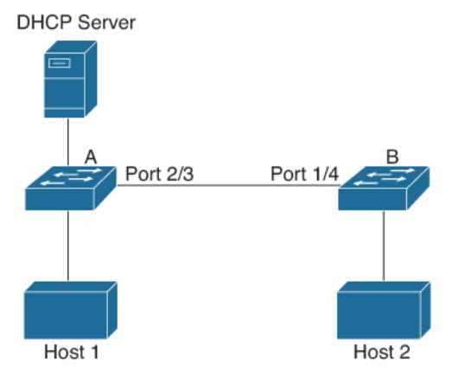

Page 812: Second Paragraph from bottom
812 | Ch 17, Second Paragraph from bottom  If you configure interfaces as trusted when they should be untrusted, you may open a security hole in a network. If device A is not running DAI, host C can easily poison the ARP cache of device B. If you configured the link between the devices as trusted, this condition can occur even though device B is running DAI. | Should read:  If you configure interfaces as trusted when they should be untrusted, you may open a security hole in a network. If device A is not running DAI, host C1 can easily poison the ARP cache of device B (and host 2, if you configured the link between the devices as trusted). This condition can occur even though device B is running DAI. If you configured the link between the devices as trusted, this condition can occur even though device B is running DAI.

Page 823: The second paragraph from the bottom
823 | Ch 17, The second paragraph from the bottom  If you are using both the Unicast Reverse Packeting Forwarding (uRFP) strict mode in your client vPC VLANs and the First Hop Redundancy Protocol (FHRP) with the DHCP relay feature, the DHCP requests are sourced from the physical egress IP address interface (not the FHRP VIP) by default. Consequently, if your DHCP server is not on a directly connected subnet and you have multiple ECMP routes back to your vPC pair, some packets might land on the neighbor switch instead of the originating switch and be dropped by RFP. This behavior is expected. To avoid this scenario, perform one of the following workarounds:  ■ Use the uRFP loose mode, not uRFP strict. | Should read:  If you are using both the Unicast Reverse Path Forwarding (uRPF) strict mode in your client vPC VLANs and the First Hop Redundancy Protocol (FHRP) with the DHCP relay feature, the DHCP requests are sourced from the physical egress IP address interface (not the FHRP VIP) by default. Consequently, if your DHCP server is not on a directly connected subnet and you have multiple ECMP routes back to your vPC pair, some packets might land on the neighbor switch instead of the originating switch and be dropped by RPF. This behavior is expected. To avoid this scenario, perform one of the following workarounds:  ■ Use the uRPF loose mode, not uRPF strict.

Page 825:
825 | Ch 17, Table 17-17:  clear ip dhcp snooping binding  interface ethernet slot/port[.  subinterface-number] | Should read:  clear ip dhcp snooping binding interface ethernet slot/port[.subinterface-number]
825 | Ch 17, Example 17-25:  Switch(config)# feature dhcp  Switch(config)# ip dhcp snooping  Switch(config)# ip dhcp snooping vlan 215 | Should read:  Switch(config)# feature dhcp  Switch(config)# ip dhcp snooping  Switch(config)# ip dhcp snooping vlan 125

Page 826: Figure 17-5
826 | Ch 17, Figure 17-5: | Should read:  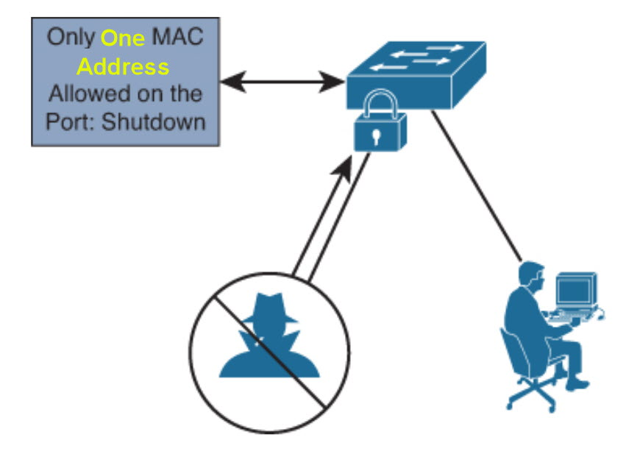

Page 842: Table 17-28
842 | Ch 17, Table 17-28:  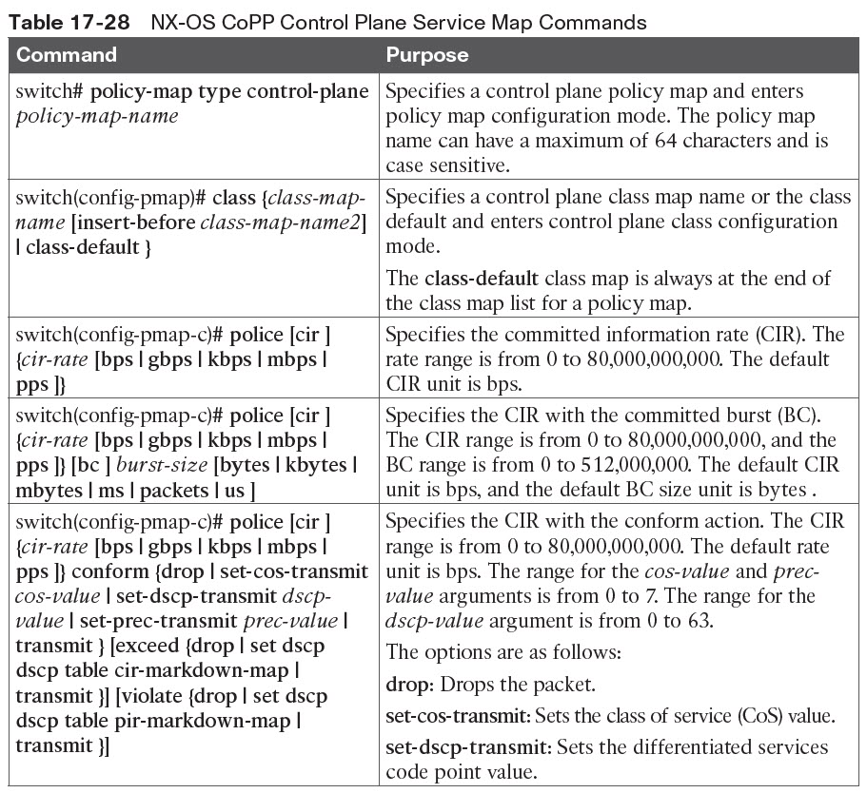  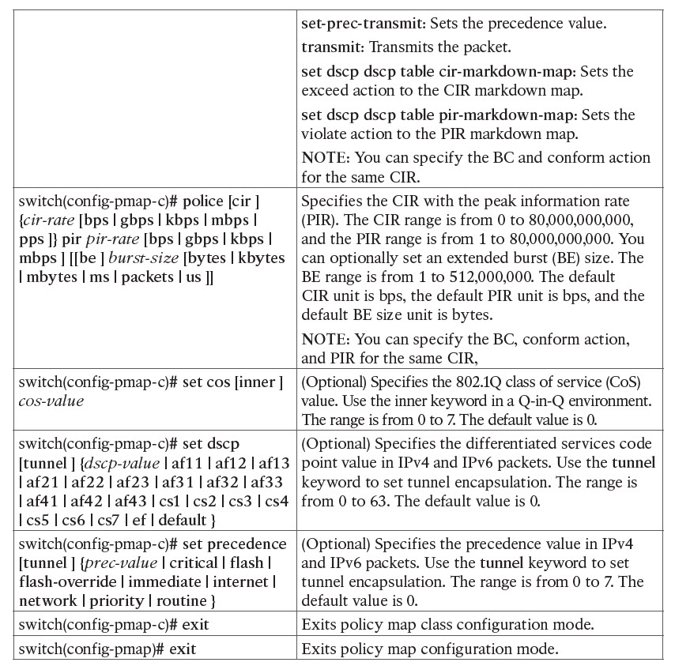 | Should read:  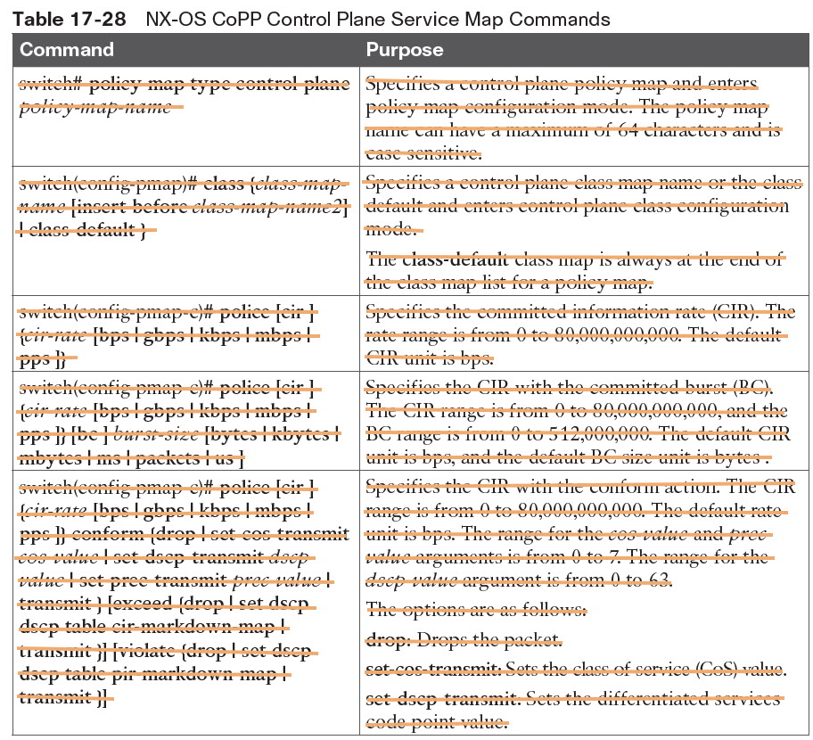  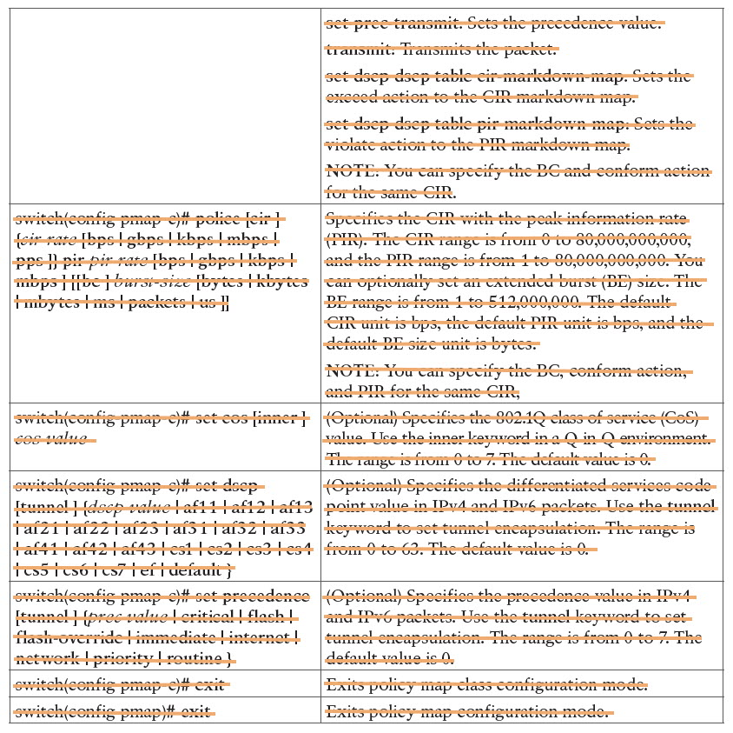
  Command | Purpose
  switch(config-cp)#service-policy input policy-map-name | Specifies a policy map for the input traffic. Repeat this step if you have more than one policy map.  You cannot disable CoPP. If you enter the no form of this command, packets are rate limited at 50 packets per seconds.

Page 856: The first paragraph from the bottom
856 | Ch 17, The first paragraph from the bottom:  As shown in Figure 17-15, all the virtual desktop VMs from the Human Resources, Finance, and Operations groups have been moved from the application EPG, EPG_VDI, to new uSeg EPGs: EPG_OPS_MS, EP_FIN_MS, and EPG_HR_MS. | Should read:  As shown in Figure 17-15, all the virtual desktop VMs from the Human Resources, Finance, and Operations groups have been moved from the application EPG, EPG_VDI, to new uSeg EPGs: EPG_OPS_MS, EPG_FIN_MS, and EPG_HR_MS.

Page 857: Figure 17-15
857 | Ch 17, Figure 17-15:  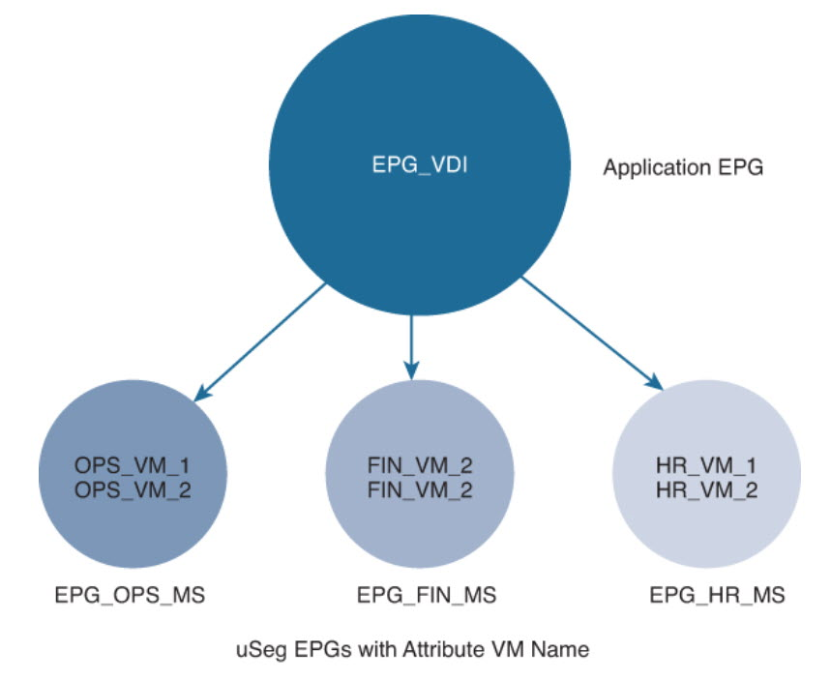 | Should read:  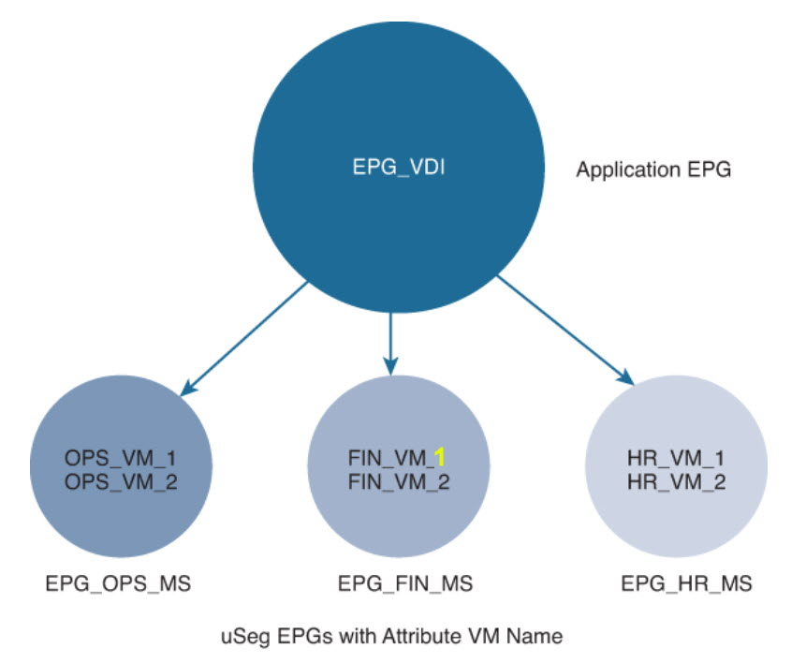

Page 859: Step 7.
859 | Ch 17, Step 7.  In the Create USeg EPG Step 2 > Domains dialog, complete the following steps to associate the uSeg EPG with a VMM domain: | Should read:  In the Create uSeg EPG Step 2 > Domains dialog, complete the following steps to associate the uSeg EPG with a VMM domain:

Chapter 18

Page 864: Third paragraph from the top

864 | Ch 18, Third paragraph from the top  Keychains Authentication: This section discusses keychain management that allows administrators to create and maintain keychains, which are sequences of keys (sometimes called shared secrets). Keychains are used to secure communications with other devices by using key-based authentication. | Should read:  Keychains Authentication: This section discusses keychain management that allows administrators to create and maintain keychains, which are sequences of keys (sometimes called shared secrets). Keychains are used to secure communications with other devices by using key-based authentication.

Page 864: Table 18-1 second line

864 | Ch 18, Table 18-1 second line  Keychains Authentication | Should read:  Keychains Authentication

Page 865: Second paragraph from the top
865 | Ch 18, Second paragraph from the top  Therefore, ACACS+ is more secure. | Should read:  Therefore, TACACS+ is more secure.

Page 866: Second paragraph from the top

866 | Ch 18, Second paragraph from the top:  The Unified Infrastructure Manager supports the LDAP protocol, as well as RADIUS, the External TACACS+ server, and the Native Registry. | Should read:  The Unified Infrastructure Manager supports the LDAP protocol, as well as RADIUS, the External TACACS+ server, and the Native Registry.
866 | Ch. 18, Authorization:  Cisco UCS user roles include the following:  ■ AAA administrator: Read/write access to users, roles, and AAA configuration. Read access to the rest of the system.  ■ Administrator: Complete read/write access to the entire system. The default admin account is assigned this role by default and cannot be changed. | Should read:  Cisco UCS user roles include the following:  ■ AAA administrator: Read/write access to users, roles, and AAA configuration. Read access to the rest of the system.  ■ Facility Manager: Read-and-write access to power management operations through the power management privilege. Read access to the remaining system.  ■ Server Compute: Read and write access to most aspects of service profiles. However, the user cannot create, modify or delete vNICs or vHBAs.  ■ Administrator: Complete read/write access to the entire system. The default admin account is assigned this role by default and cannot be changed.

Page 878: Figure 18-7

878 | Ch 18, Figure 18-7  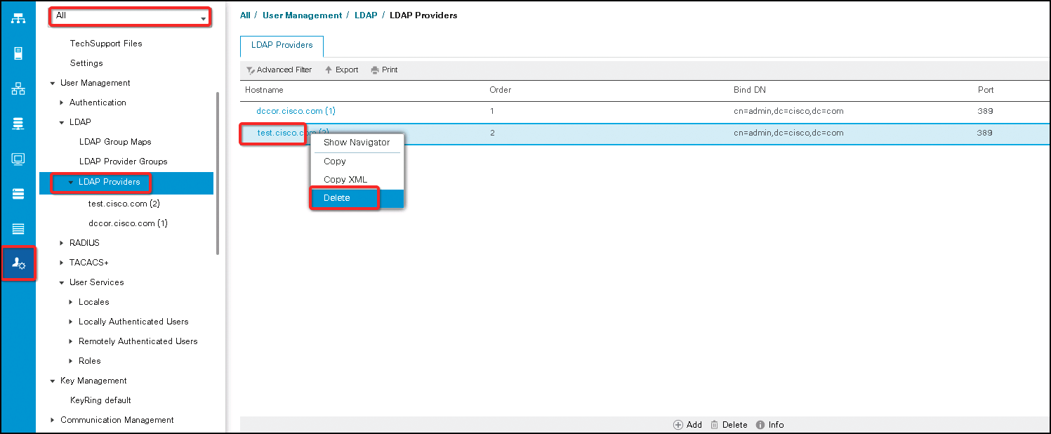 | Should read:  Please see corrected image for Figure 18-7 in the zip file named “Ch 18 Corrected Image.zip” attached.  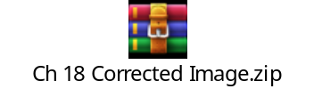

Page 884: First paragraph from bottom
864 | Ch 18, First paragraph from bottom  Keychains Authentication  NX-OS Keychain management allows you to create and maintain keychains, which are sequences of keys (sometimes called shared secrets). You can use keychains with features that secure communications with other devices by using key-based authentication. The device allows you to configure multiple keychains. | Should read:  Keychains Authentication  Public key infrastructure (PKI) services provide a scalable and trusted method of authentication. UCS Manager supports PKI only for the web sessions(https) to establish secure communication between the Client’s browser and UCS Manager for management purposes. To know more about UCS Manager Communication Services, refer to the “Cisco UCS Manager Administration Management Guide”.  350-601 DCCOR blueprint includes Keychain Authentication under Compute Security, whereas it should be part of Network Security. We are placing this section here to reflect the blueprint flow of topics. This section discusses Keychain management on NX-OS and not UCS.  NX-OS Keychain management allows you to create and maintain keychains, which are sequences of keys (sometimes called shared secrets). You can use keychains with features that secure communications with other devices by using key-based authentication. The device allows you to configure multiple keychains.

Page 889: Table 18-9

889 | Ch 18, Table 18-9 Line 7  Keychains Authentication | Should read:  Keychains Authentication

Page 944: Chapter 11, Answers to the “Do I Know This Already?” Quizzes
944 | Ch 11,  2. A, D. In a blade chassis, the FEX fabric link (the link between the FEX and the FI) supports two different types of connections:  - Discrete mode  - Port channel mode | Should read:  2. B, D. In a blade chassis, the FEX fabric link (the link between the FEX and the FI) supports two different types of connections:  - Discrete mode  - Port channel mode

Corrections for May 6, 2020
Pg | Error – First Printing | Correction
940 | Chapter 4, answer to Question 1:  C, D. In a two-tier CLOS architecture, every lower-tier switch (leaf layer) is connected to each of the top-tier switches (spine layer) in a full-mesh topology. APIC connects to leaf devices only. | Should read:  B, C. In a two-tire CLOS architecture, every lower-tire switch (leaf layer) is connected to each of the top-tier switch (spine layer) in a full-mesh topology. Every leaf switch connects to every spine switch in the fabric. The ACI fabric provides consistent low-latency forwarding across high-bandwidth links (40 Gbps and 100 Gbps). APIC connects to leaf only.

Corrections for March 23, 2020
GLOSSARY:
Page 6: "FCoE Fibre Channel over Ethernet (FCoE)" – change to “Fibre Channel over Ethernet (FCoE)"
Page 10: Please delete "MAC address" (first term under M).
Page 13: "Path MTU Discovery (PMTDU)" – change to "Path MTU Discovery (PMTUD)"
Define Key Terms
Ch 4: “application programing interface (API)” – change to “application programming interface (API)”
Ch 17 and 18: “Terminal Access Controller Access Control System (TACACS+)” – change to “Terminal Access Controller Access Control System (TACACS)”.

Corrections for February 14, 2020
Pg | Error – First Printing | Correction
Practice Test | Ch 5, (e) Unicast Traffic over OTV:  The OTV edge will encapsulate the Layer 2 packet over Layer 3 and transport it to the OTV remote edge, | Should read:  The OTV edge will encapsulate the Layer 2 frame over Layer 3 and transport it to the OTV remote edge,

This errata sheet is intended to provide updated technical information. Spelling and grammar misprints are updated during the reprint process, but are not listed on this errata sheet.

